**Event Driven Microservices using Spring Boot | Full In-depth Course**

We are going to learn event-driven architecture using spring-boot. So, we are going to learn the different design-patterns, different architectural design-patterns to learn more about the event driven architecture. So, we are going to learn about the **CQRS design** **pattern** and **Saga design pattern**. Why these 2 because these 2 are the mainly used design patterns in a microservices. **Which will allow us to create a very scalable application and saga design pattern also allow us to create a microservices that will handle the distributed transactions.**

In this part we will use the AXON framework and AXON Server alongside with SpringBoot, but we can use different framework or server as well. Just understand the concepts.

**CQRS Design Pattern**

CQRS means **Command and Query Responsibility Segregation**. So, that mean we will be Segregating the Responsibility of a Command and a Query in a different way. To understand what a Command is and what a Query is let’s first understand our traditional flow or traditional architecture how we are building the application and how we can improve upon to implementing the CQRS. Now, one thing to understand is, **this CQRS we are going to implement using the event driven architecture.**

So, **To develop event driven architecture we will use the event sourcing to interact with each other**. So, first let’s understand the standard structure over here.

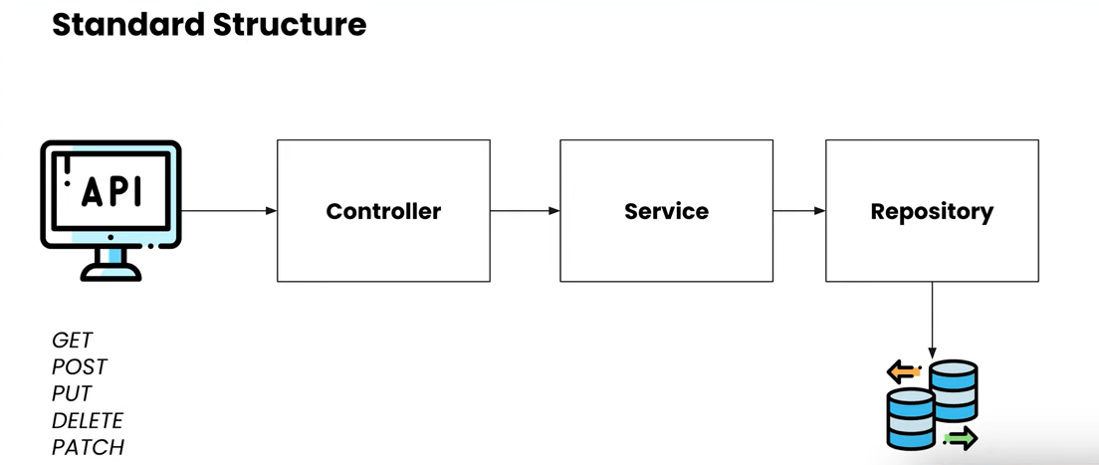

So, In the Standard Structure you might have seen multiple times like we will be creating the API, those API’s might be having the different HTTP Method Types **GET**, **POST**, **PUT**, **DELETE**, **PATCH**. So, you are creating the API and your API is controlled by your Controller Layer. So, that Controller Layer will be responsible for Traversing the Request to the each of the different Services that you have in your application. So, from the Controller your Request will be going to the Service Layer that Service Layer responsible for your Business Logic. So, whatever the business logic that you have for your application that you are building all those particular logics should be written in **Service Layer**. So, from the Service Layer you will be calling the **DAO Layer** or **Repository Layer** to save your data or to persist your data to the database. so, this is a very standard structure for creating a Spring MVC application or a standard Microservices as well.

**But here let’s understand the CQRS Architecture, how it is different from the normal Architecture and what are the different things we are going to see over here.**

Now the first thing we can see over here is we will be creating the API over here as we are creating the API in standard structure but the only difference is How and what are the different **HTTP** Method’s we are going to use. So, all the method that is to fetch the data i.e the **GET** method. We will be implementing the GET method to Fetch the data that particular will be implemented by the **Query API**.

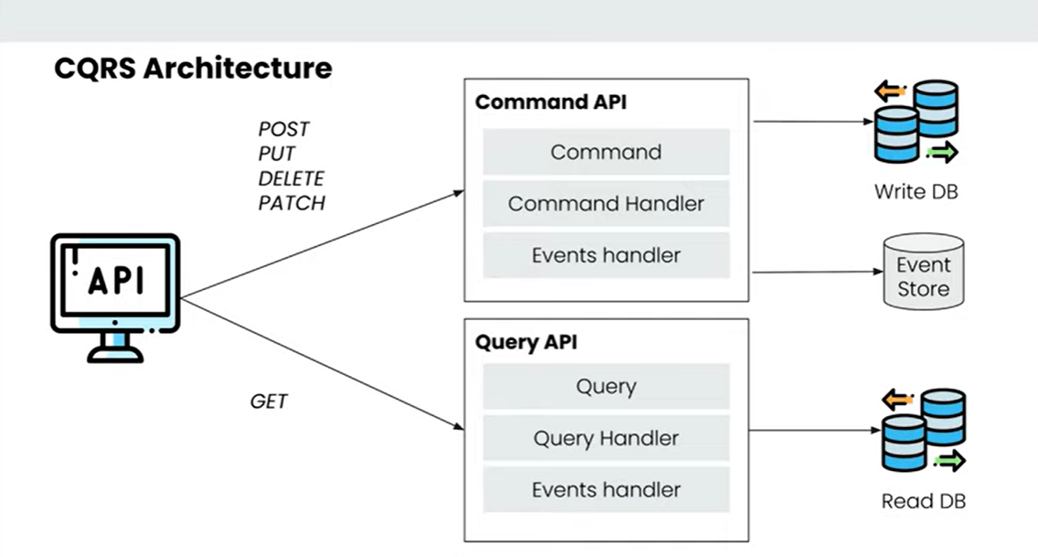

This is the very basic level architecture we are seeing over here…

And all the other methods that is **POST, PUT, DELET** and **PATCH** those are used to add the data, modify the data, and update the data that will be implemented by **Command API**. So, this is the 2 differences.

Whenever you are providing any Command to your Application to do any of the operation that will be handled by the **Command API** and whenever you want to Fetch any data that is already been added to your System to Fetch that you will be using **Query API**.

**Now, the differentiation of this Command API and Query API is the Core Concepts behind the CQRS.**

**i.e To Segregate the responsibilities of the Command’s and your Query’s that you have in your System.**

Ideally when you develop the System both of this particular command and query will be in different services so you can configure your system according to the need of the application. So, you are creating the Query API. you can tune the application to get the data and when you are using the Command API you can tune the application to store or update the data into a database.

So, for each and every Command API and Query API the main thing you are going to do is, for the Command API you will be providing the Command to execute any of the Command and for the Query API you will be providing the Queries to Fetch any of the data available. So, these are the 2 things that you will be providing in the System to do any of the operations over here.

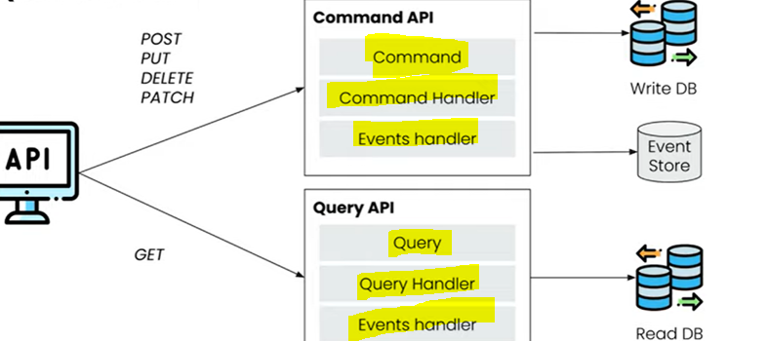

Now, for the **Command** to Handle all this particular command’s there will be a **Command Handler** that will be handling the command. and for the **Query** there will be a **Query Handler** that will be handling the queries.

Now this particular Command Handler also known as the **Aggregate.** when you will be developing the application will be creating the **Aggregate**, that particular Aggregate will be handling all the commands and for the queries we will be creating the **Projections**, that particular Projection will be handling your all queries. You can create the **Command Handler** classes as well and **Query Handler** classes as well. But you can also create the **Aggregate** and **Projection** as well.

So, I have seen multiple places where people have been using Aggregate and Projection and Command Handler and Query Handler as well and for Each and Every Command or Each and Every Query that you handle you will be creating the Events, so with that particular event your system can handle all the particular operations because we are going with the event-driven-architecture over here. All the particular events will be store into **Event Store**. Now for the **Command API** we will be storing data into the **Write Database** that means whatever the operations we do that particular database is configured for writing the data to that particular database. For the **Query API** we will be using the **Read Database** which is configured for reading the data from that particular database.

So, the question is whenever you store data into Write Database using the Command API how that particular data comes to the Read Database. so, those data come using the Events as well so for those type of operations also we will be creating the **Events** to store the data from the **Write DB** to the **Read DB**.

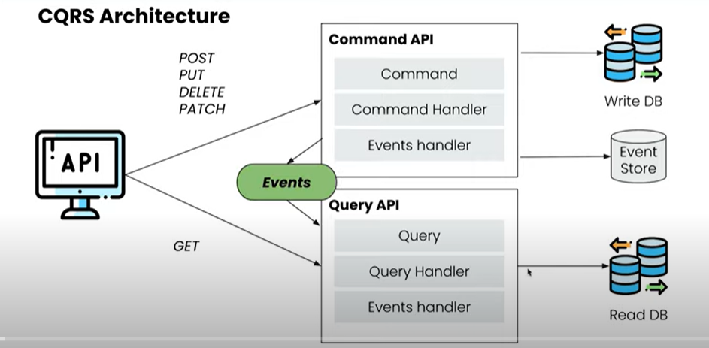

Now let’s see How to Implement the CQRS using the **Spring Boot** and **AXON Server**.

AXON Server provides the ability in this Spring Boot Application to handle all our different events and commands and store all our particular data in our Event Store. So, what we will be doing is we will be using the AXON server as well. So, that particular AXON server will store all our data and we will be using the AXON framework to interact with the particular AXON Server.

**Let’s understand the Data Flow for our Command API the similar thing will be available for the Query API as well**

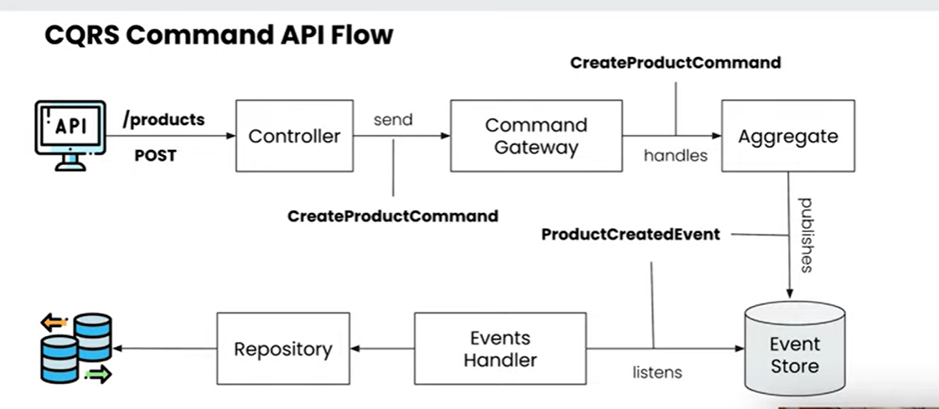

So, this is a CQRS command API flow where we have taken one example to save one of our products. So, we have a Product Service available, and we are going to save the product using the **POST** Request. So, here u can see that we have an API **/product,** and we are doing the **POST** request and we are having one **Controller,** this particular controller will be handling all our API Request, and based on the particular API’s that we are going to call based on the different **HTTP’s** methods. We will be sending the **command** to our **Command Gateway**. so, what is the command over here you can see that I have created a command called **CreateProductCommand** so, I am going to create any product using the **POST** method over here. So, I have added the command **CreateProductCommand.** you can create multiple commands like **UpdateProductCommand**, **DeleteProductCommand** based on the requirements and those particular commandsI am sending to the **Command Gateway.** I am creating **Aggregate** as well; **Aggregate** is nothing but a **Command Handler** over here which will handle all the commands which we are passing. So, this particular Aggregate will handle this particular command **CreateProductCommand** and whatever the operation like we have to do like validations and all those things we can do. We can create the **Event** like **ProductCreatedEvent**. So, if whatever the data we are passing over here if I think everything is ok then I can create the Event **ProductCreatedEvent** and that particular event will be store to an **Event Store**. We will be creating one **Event Handler** and that particular **Event Handler** will listens all of the Events which has been created and stored into **Event Store**. It will try to listen all those events and it will complete all those events. So, in this particular **Event Handler** what this particular Event Handler doing is it is trying to listen this particular **ProductCreatedEvent** over here. So, whenever a new event **ProductCreatedEvent** created and stored into **Event Store** it will consume that and it will listen that particular eventand this particular Event Handler will store that particular data into our database using our **Repository** so, this will be our **Write Database**.

So, this is the entire flow **event-driven-architecture** flow for our **command** for a CQRS this is for our Command parts.

So, this is the flow which we are going to use to create the different **Command** and create the different **Events**. according to the particular **Commands** handle those particular **Events.**

So, for the **Query API** this would be very similar there would be one **Controller** that will handle the particular API instead of **Command Gateway** there would be a **Query Gateway** that will handle those **Queries** and instead of **Aggregation** there would be a **Projection** that will handle those particular Projection and same it will have an **Event Handler** which will handle the events or we can directly send the data from the **Projection** as well.

So, we are going to create a Particular Product Service to create a Product and get the data from the particular products. So, this is the same flow we are going to create one Controller, Aggregate, Event Handler and Repository for saving the products.

Before start to do the Coding, let’s first understand what is **Event Store** is over here… so, let’s go to the **AXON Server Website** and from there we can understand the Event Store.

<https://developer.axoniq.io/event-sourcing/overview>

### **What is Event Sourcing?**

In a traditional way of storing an application’s state, we capture the current state and store it in some relational or [NoSQL](https://en.wikipedia.org/wiki/NoSQL) database. While this approach is really straightforward, it does not provide a way of deducting how we got to that current state. Of course, one may argue that we can have a separate model for keeping the history of actions that lead to the current state. Still, besides the additional complexity, these two models could easily go different paths and start being inconsistent (which is basically an [update anomaly](https://www.sqa.org.uk/e-learning/MDBS01CD/page_22.htm)).

Event Sourcing is a way of storing an application’s state through the history of events that have happened in the past. The current state is reconstructed based on the full history of events, where each event represents a change or fact in our application. Events give us a single source of truth about what happened in our application. It is especially beneficial in applications that need to provide a full audit log to external reviewers. The current state is called **Materialized state** in some resources. The following figure represents the reconstruction of materialized state based on the history of events.

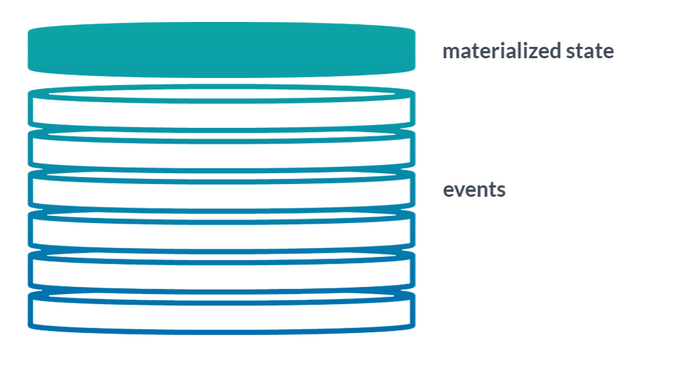

So, AXON Server using this Event Sourcing technique to store all of the particular events. So, whenever we create a particular event from our Command Gateway all the particular events will be store to our Event Store over here.

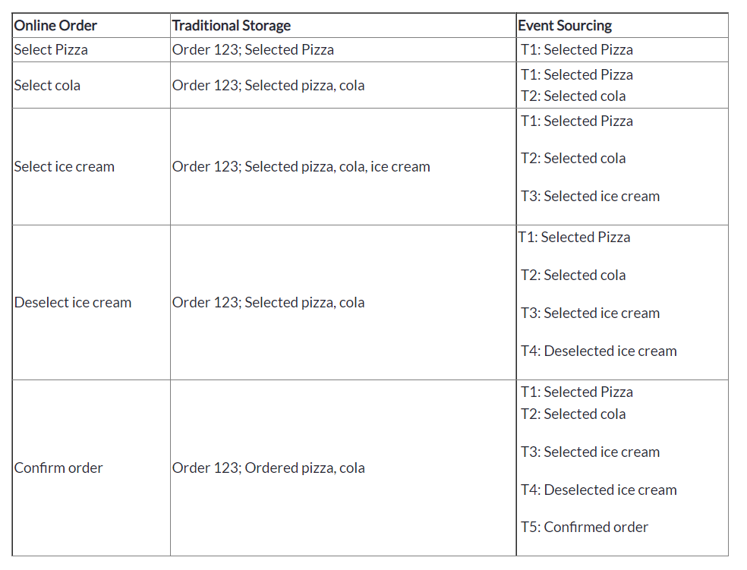

So, here lots of events is happening. All these particular events like selecting the pizza, selecting the cola then selecting the ice-cream and then de-selecting the ice-cream and then performing the order. all these particular events that are happening are stored inside the **Event Data Store** and all these particular events at the ends will result in a single data that has been read by the **Read Database**. all these particular events executed and results in a single order over here and that single order will be store in a database over here.

Why this particular event-sourcing is so helpful is whenever you have an issue, or you want to re-create the same order you can play the entire this particular event source from start to end to create the same data that you want. You can always go and do select a pizza, select a cola, select an ice-cream and de-select an ice-cream and order it. So, in that way you were able to re-create the same order multiple times for our debugging purposes or you want to create a new database lot of things u can do using the event-sourcing. You can do the snapshots and event Replaying as well.

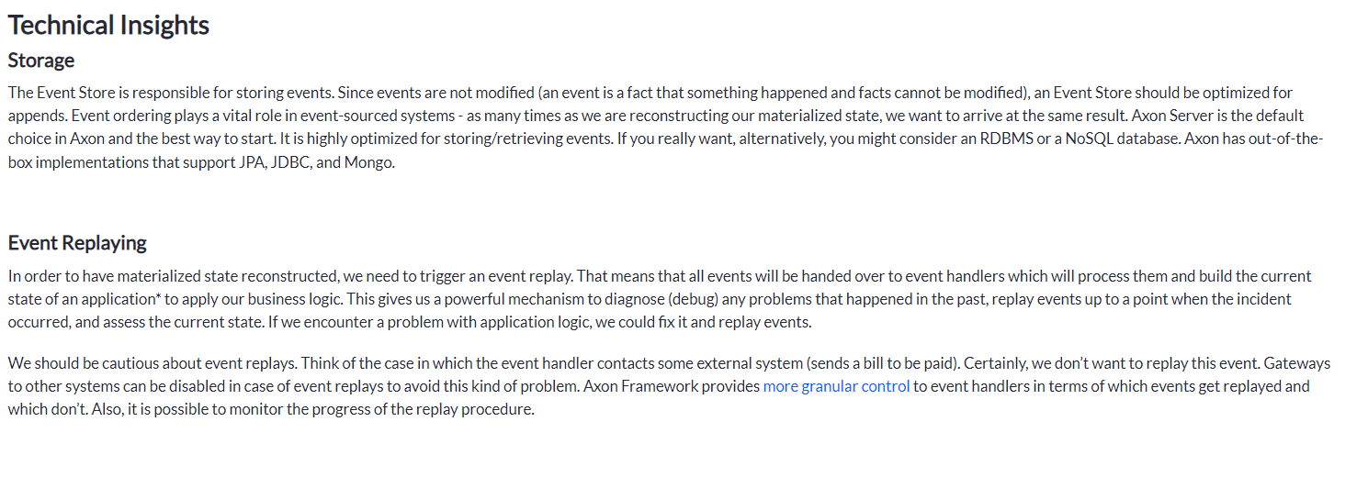

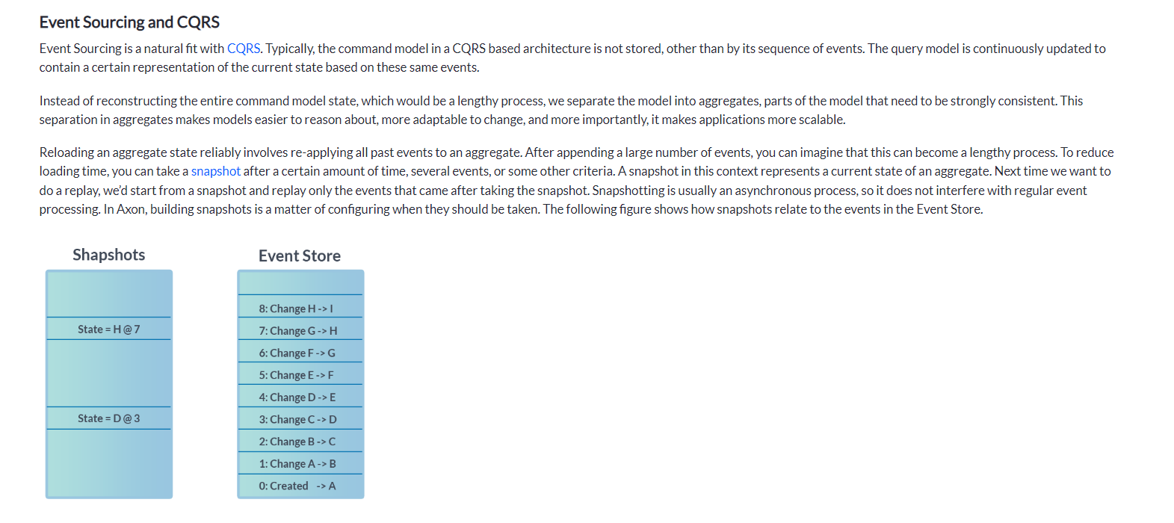

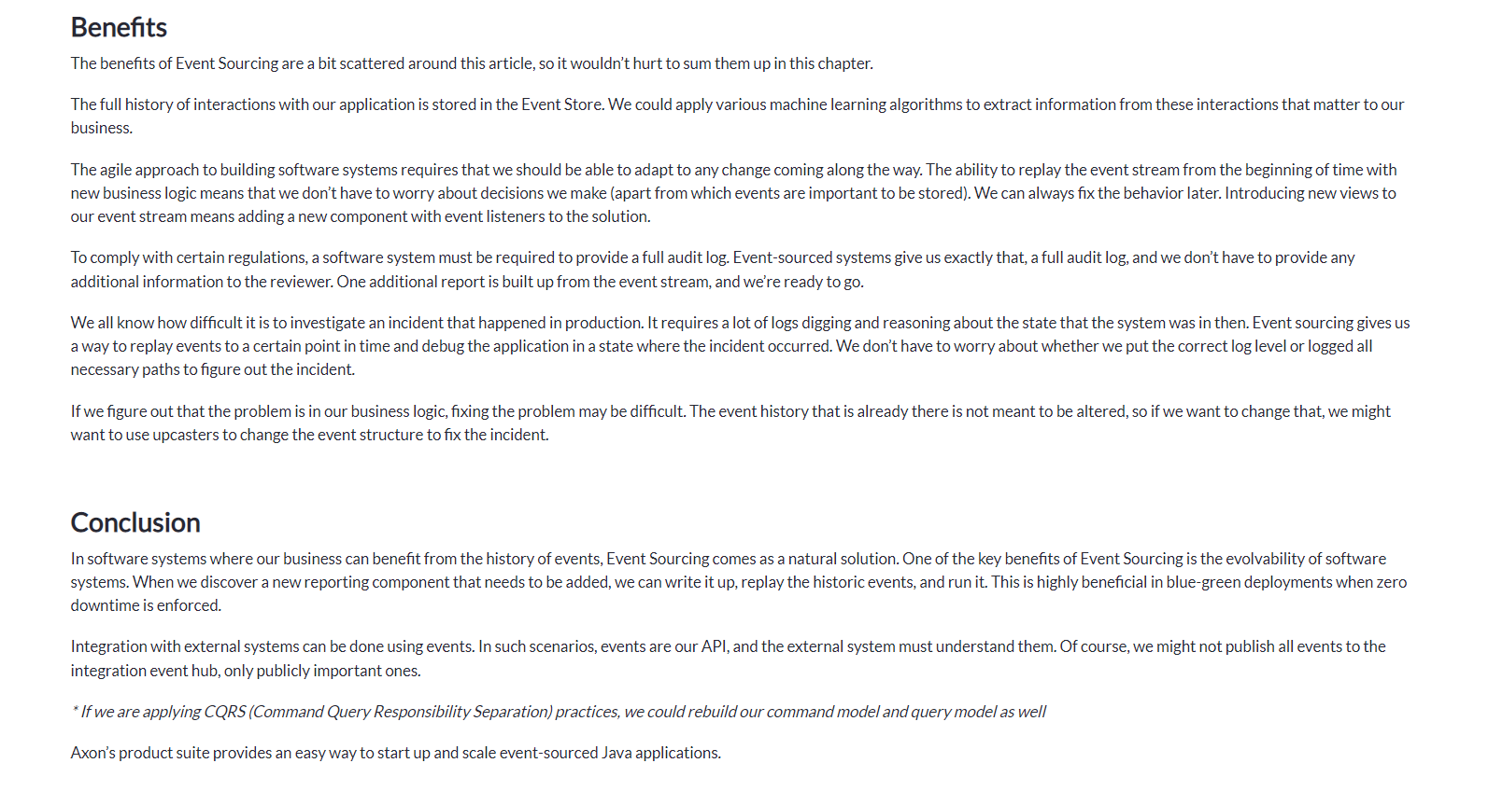

To download AXON Server please go to the below link--🡪

<https://developer.axoniq.io/download>

download AXON Server zip folder…

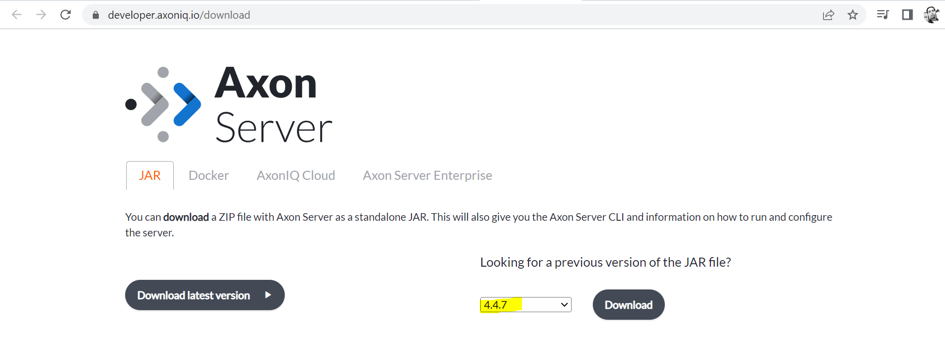

Now let’s go to the Spring Initializer and create the project –

<https://start.spring.io/>

I will add Lombok to remove boiler plate code. Here I am using H2 database, but it will work in any of the database.

Application Name: **ProductService**

Dependencies - **Spring Web, Spring Data JPA, H2 Database, Lombok**

Unzip the AXON Zip folder and open the terminal… I have putted AXON unzip file in C drive

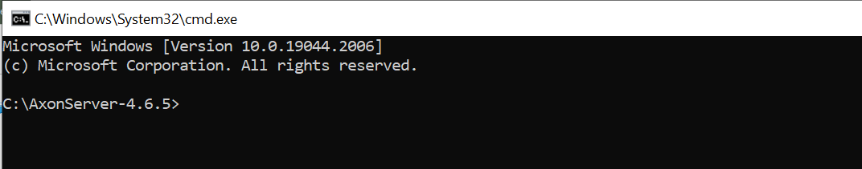

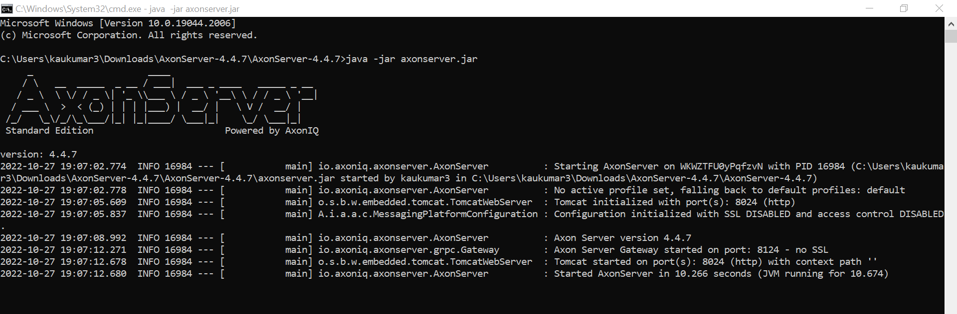

We can see our axon server started over here which is running on port **8024.** So below is our **AXON Dashboard,** so here we can see that how many events are there.

<http://localhost:8024/>

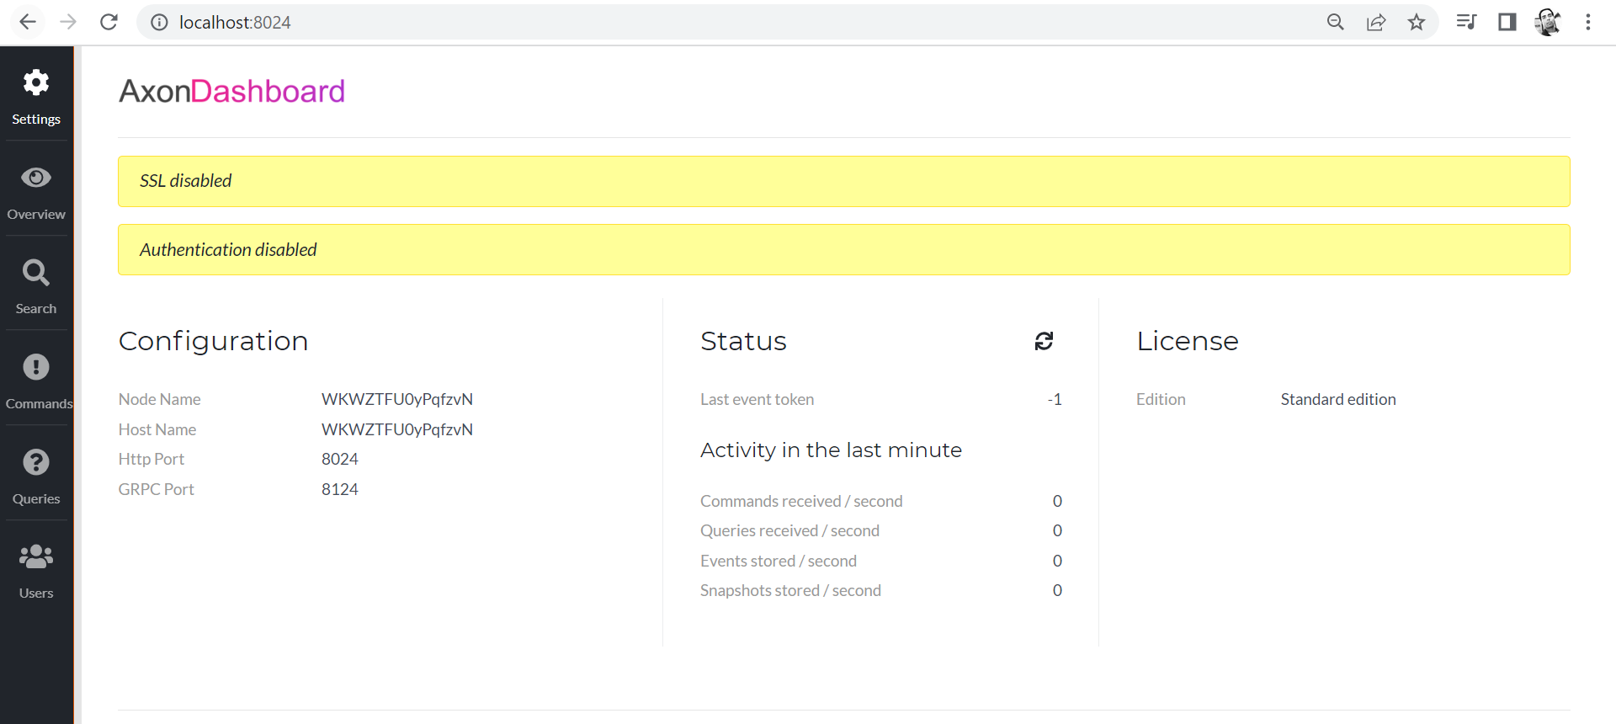

**Below one is the overview of this so here there are no application connected over here.**

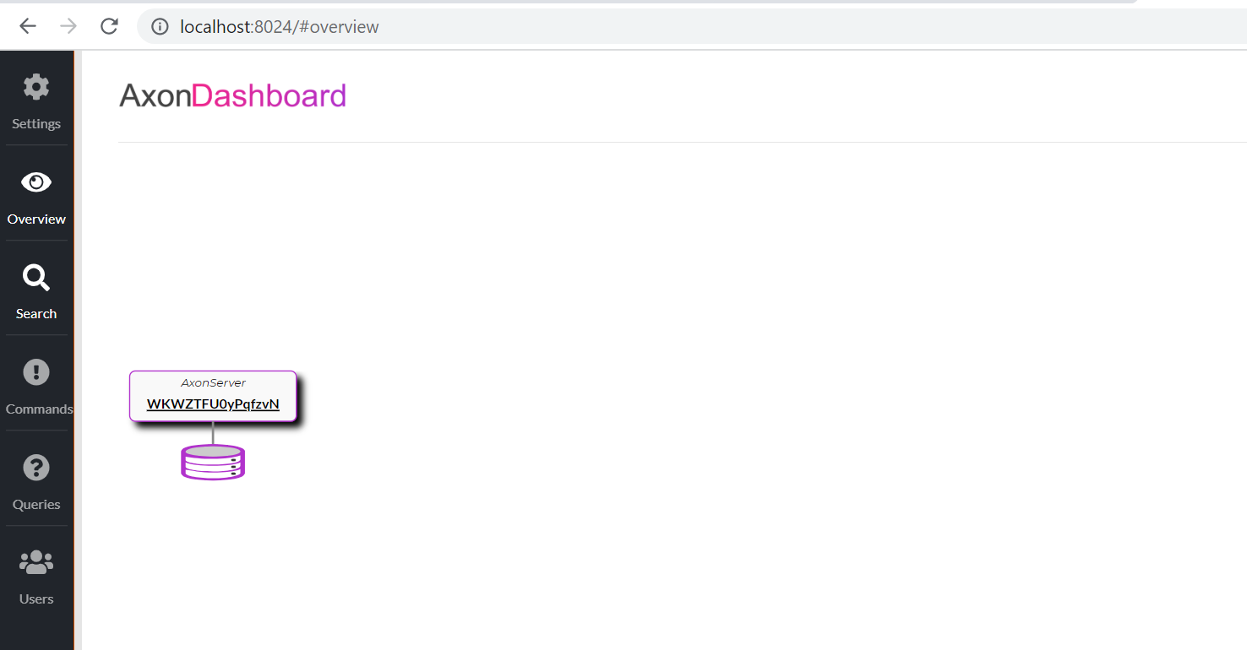

**You can search all events and snapshots available, let me just select the live update for now.**

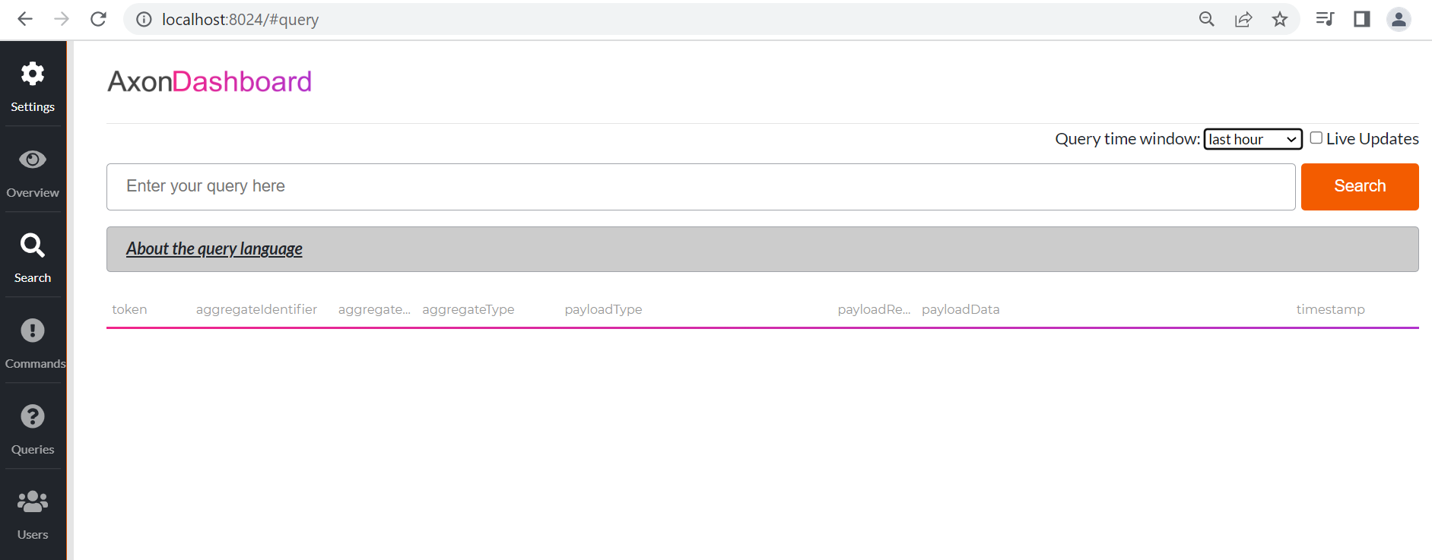

**Here you can see that all of the different commands, whatever the commands you have created those particular commands will be populated over here.**

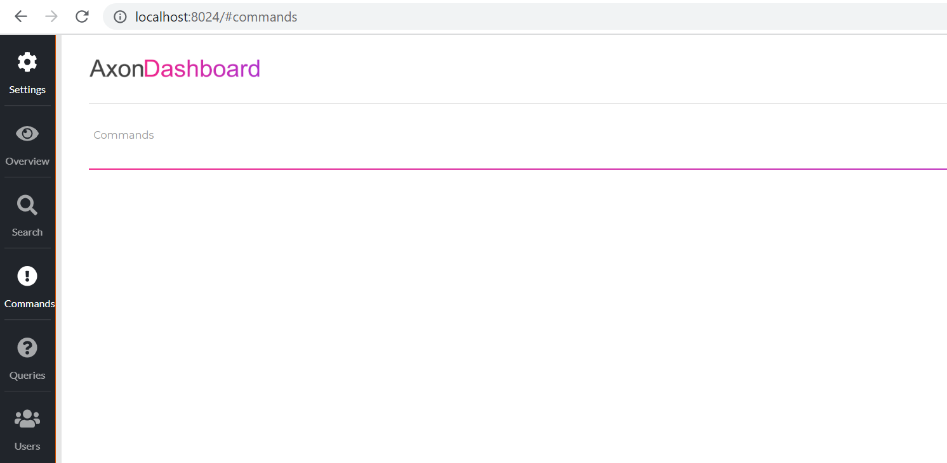

**All of the different Queries will be populated over here.**

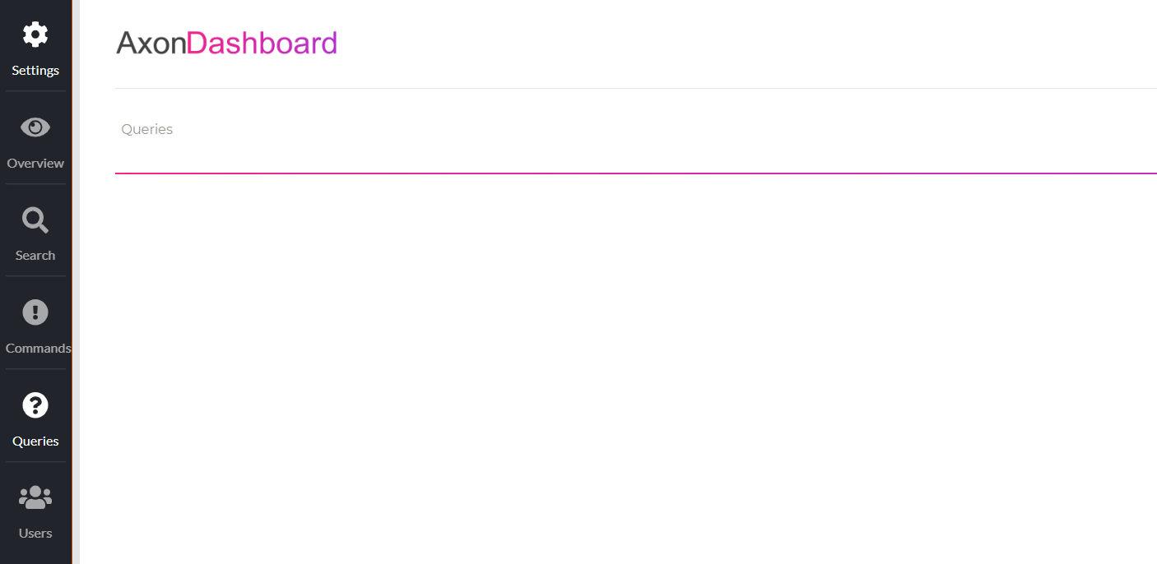

**So, this is the AXON Server Dashboard, we will keep this aside and we will go to the Project over here. go to the pom.xml.**

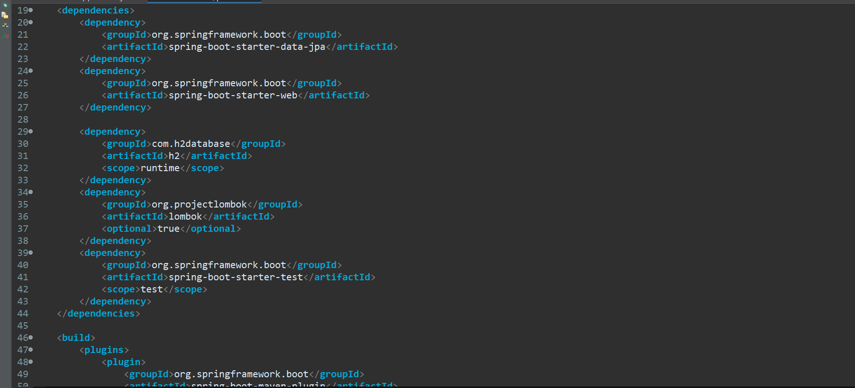

**So, here we need to add the Axon Framework.**

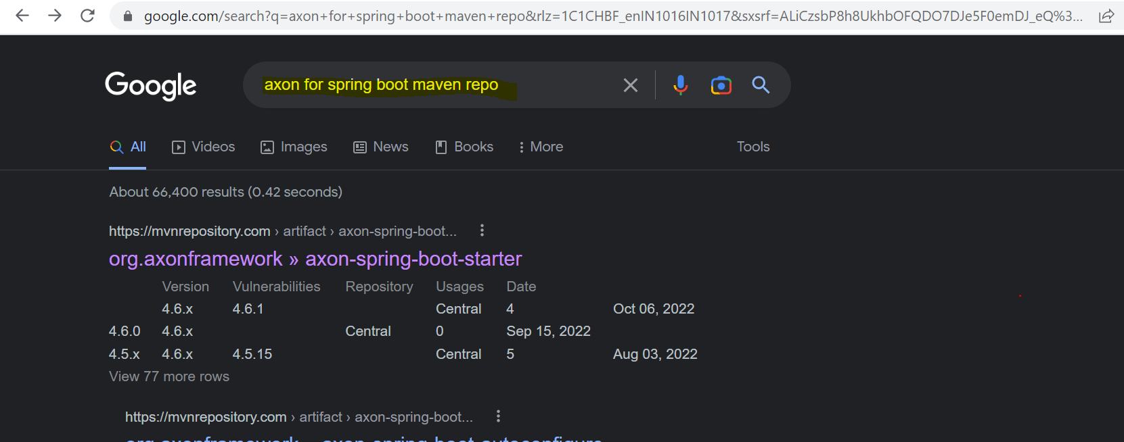

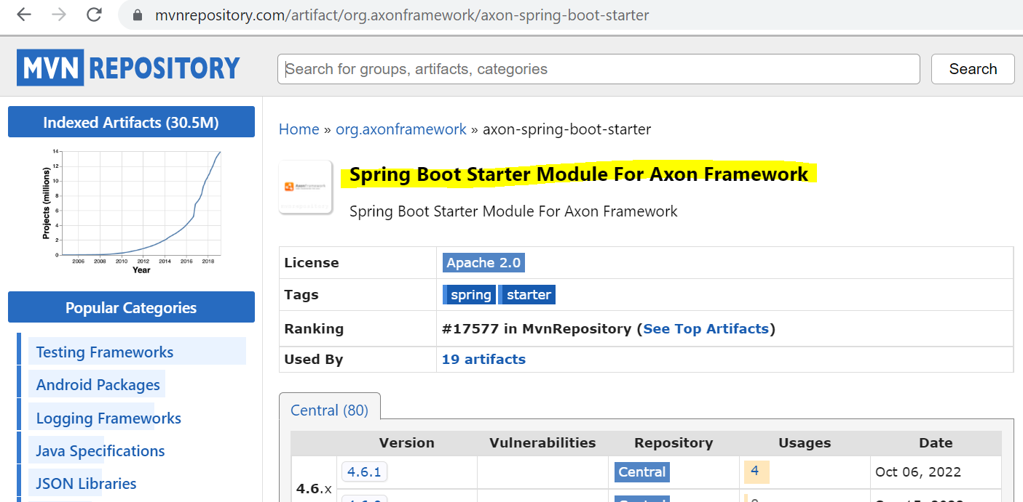

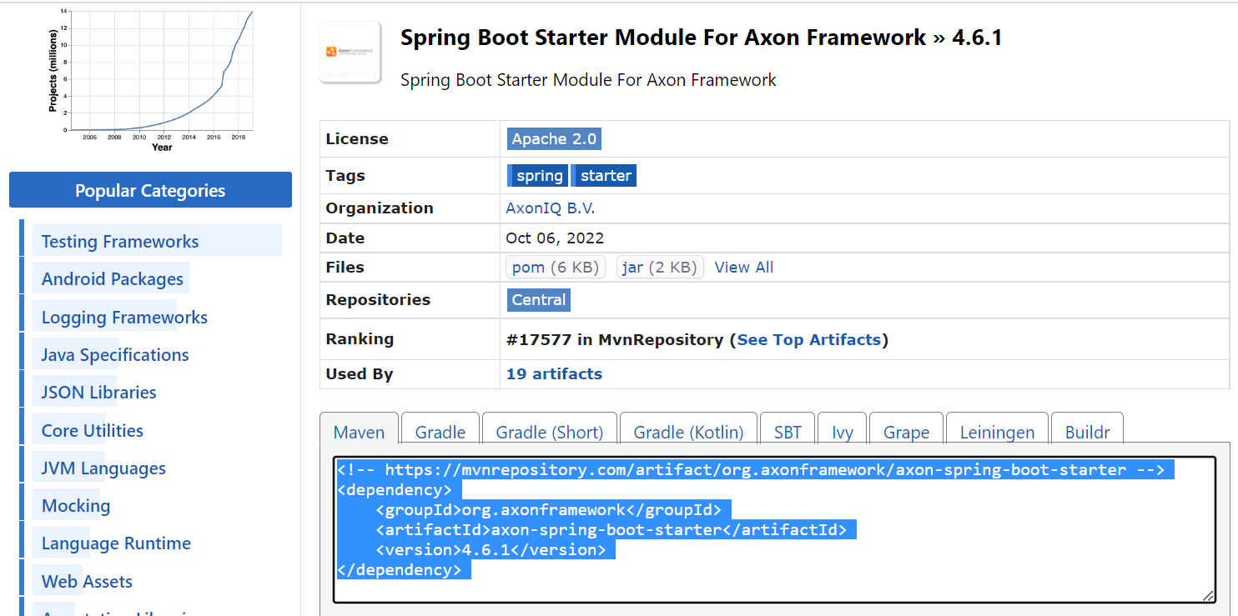

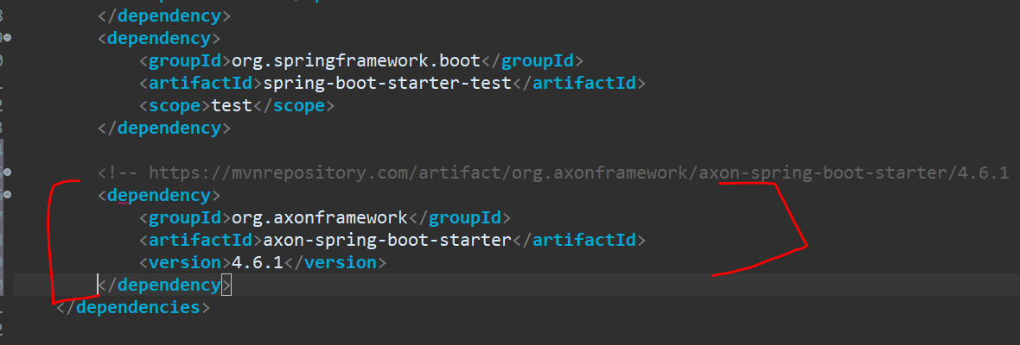

And this particular AXON Framework also needs the Google’s Guava dependencies as well.

So, let me add that as well

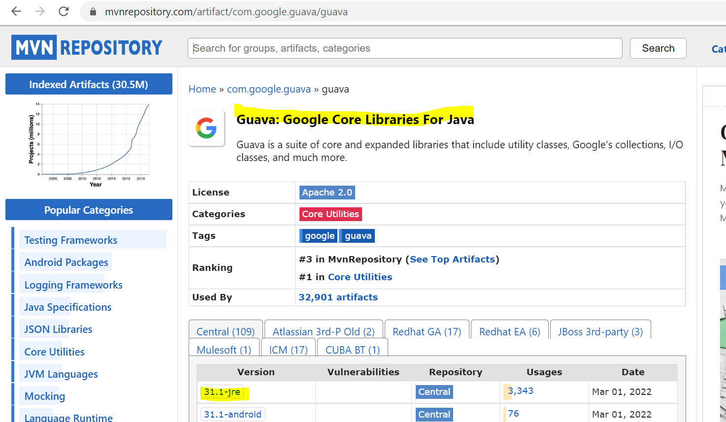

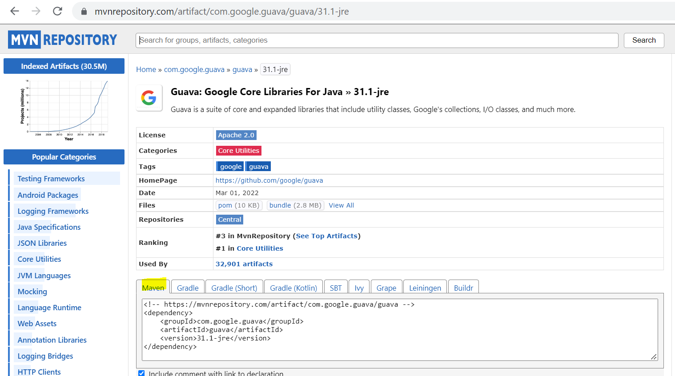

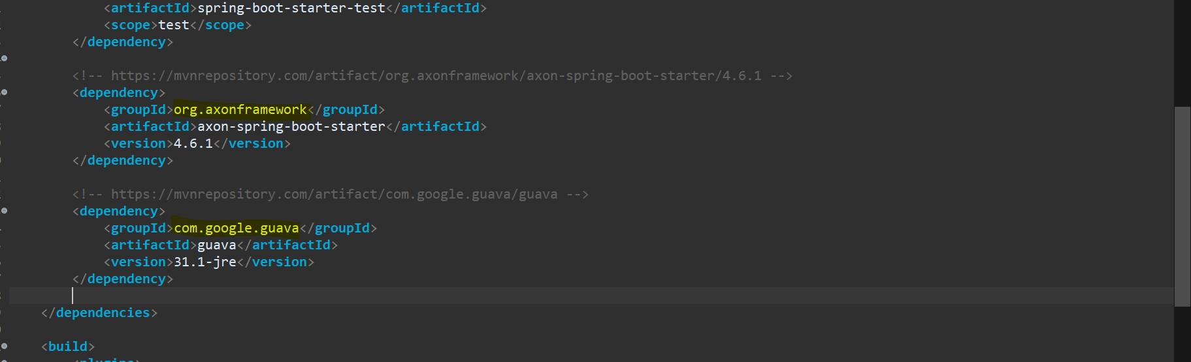

So, now let’s resolve our dependencies and restart our application.

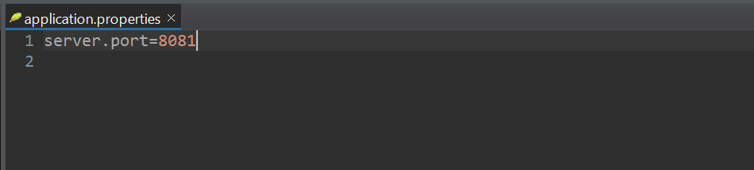

Let’s add server. port in our properties file. now let me add the properties for the H2 database.

What I am doing over here is

~~#spring.datasource.url=jdbc:h2:mem:testdb~~

**spring.datasource.url=jdbc:h2:file:~/data.productDB**

**so, this particular H2 database will store all the data not In Memory but in the file at this particular location over here.**

let’s create a packages….commands.api for our commands and query.api for our queries.

Inside this particular **command.api** we can create the different packages based on the different controllers, Aggregates, and all other things. So, here what we are going to create is **Controller**, **Aggregate** and **Repository**. So, we will be creating this **CreateProductCommand** and **ProductCreatedEvent** as well.



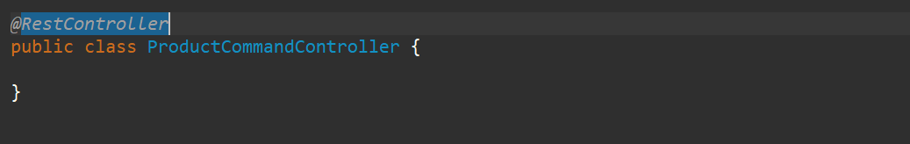

So, this is the Rest Controller where we can interact with the JSON data. and I will also use the @**RequestMapping** annotation, and I will create a method to save the products.

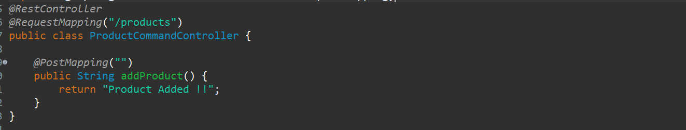

But we need to add the Product over here. we need to get the data from the JSON as well. So, we need to have a Rest Model as well that we will be collecting the data from. So. Let’s create the model as well.

So, in the model we will create a class over here.

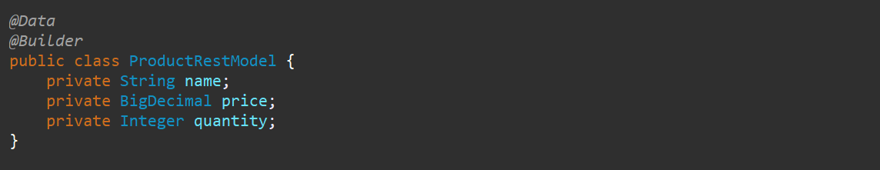

And let me use this ProductRestModel in my command controller.

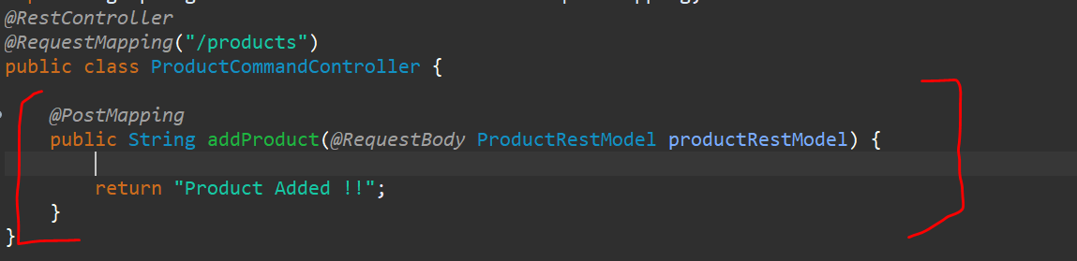

So, this is pretty standard implementation of our REST API.

Now what we want to do is from this particular controller we need to send this particular data to the Command gateway over here.

So, let’s create the object of CommandGateway over here which is the part of AXON Server. And I will inject using the Constructor injector over here.

So, this is the particular CommandGateway we can use but we want to send the command i.e **CreateProductCommand.** so, from the Controller we are sending the Command **CreateProductCommand** to the **CommandGateway** over here. so, we need to create this particular **CreateProductCommand** as well.

Go to the commands.api package and create one package with name **commands.**

Now all the particular commands and events will be having this state of what we are going to do. Suppose I am going to save a particular product so this particular command and this particular event which we are going to create should store the state and should store the payload of what I am going to do. So that way only whenever we are creating the events and whoever is consuming the events will get to know what are the data available and what we need to do with that particular data.

So, always whenever we are creating the commands or events will be storing the data or will be storing the payload inside that particular object.

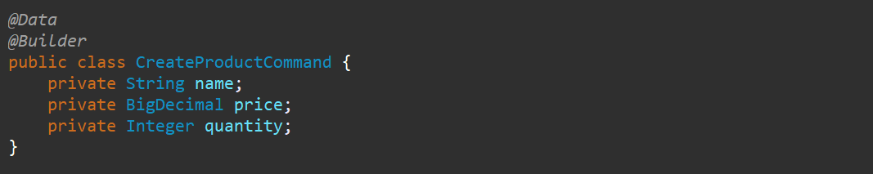

Now, along side all details there will be always one identifier that would be your **product_id**.

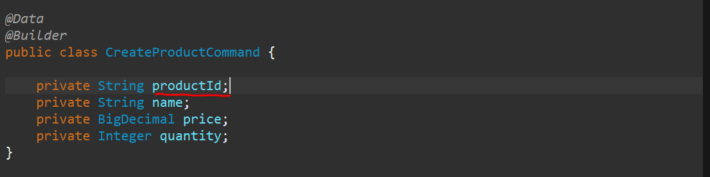

Now for each of the particular command and Aggregate which is handling each of the particular command should have something in common. So, there would be multiple products available and your Aggregate that is your Command Handler will be handling all of those particular products. For all those particular products your product_id is unique so, that particular product_id should be annotated with some Annotation so that your Aggregate will understand this is a Target and this is a particular id that I have that will match the particular 2 id’s and accordingly the data would be processed. So, this particular product_id I will annotate @**TargetAggregateIdentifier**.

So, when you will be creating your Aggregate i.e your **CommandHandler**, we will be having this particular(productId) field over here. that it will interact with. So, both the particular command and aggregate will compare this 2 particular fields to match this values. So, once we implement this you will get more clarity on this why we are doing this.

Now we created the Command, so I need to add the Payload data to this particular Command, and I need to send this particular command to my CommandGateway. So let me go to the Controller and here what I will do.

I will create the object of particular **CreateProductCommand,** and I will add all the values from the **ProductRestModel**.

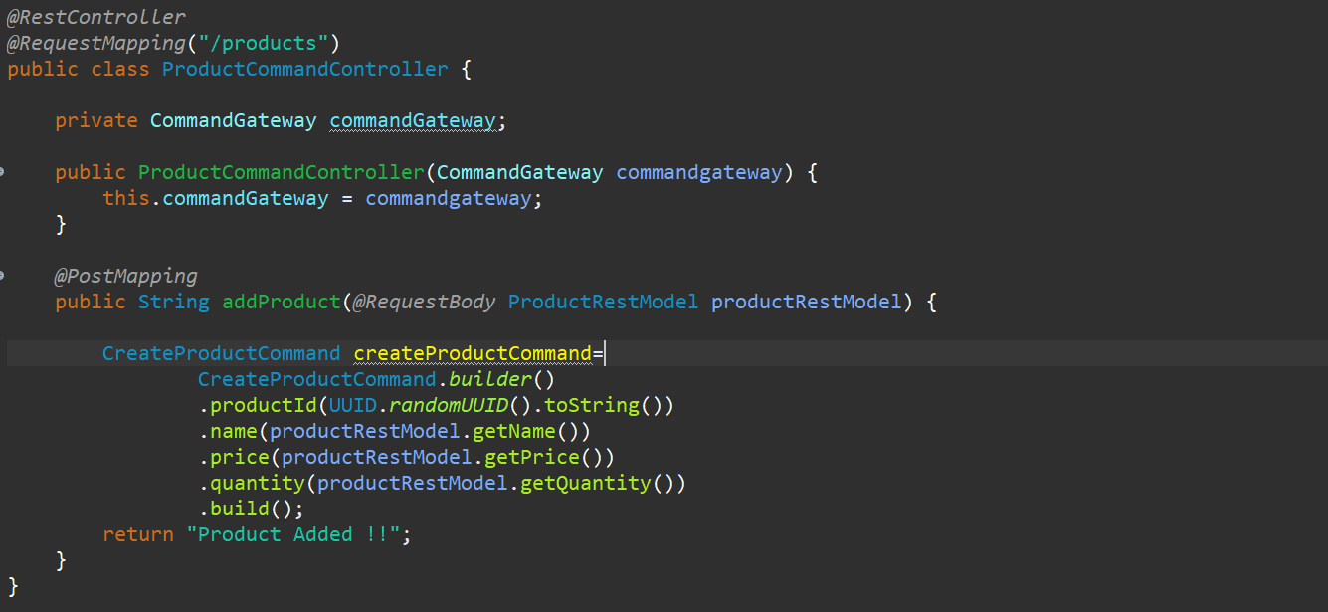

Here you can see that your object is created, and you have set all the fields and all the data that you are getting from the API Request to your Command over here.

Now you need to send this command via **CommandGateway**.

***CommandGateway.sendAndWait(Command command)***

So, send this particular command and just wait till this particular command gets completed.

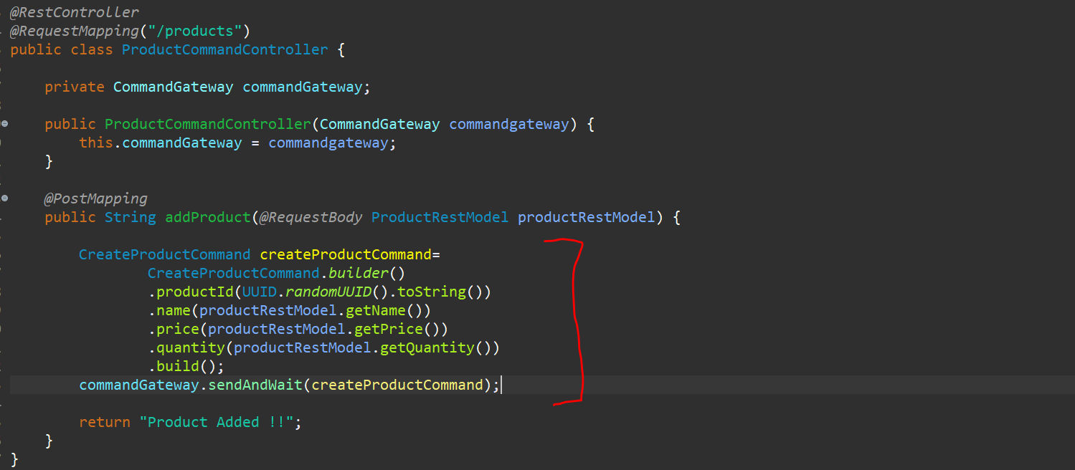

Now, this particular method will return the result and let me send it back result over here.

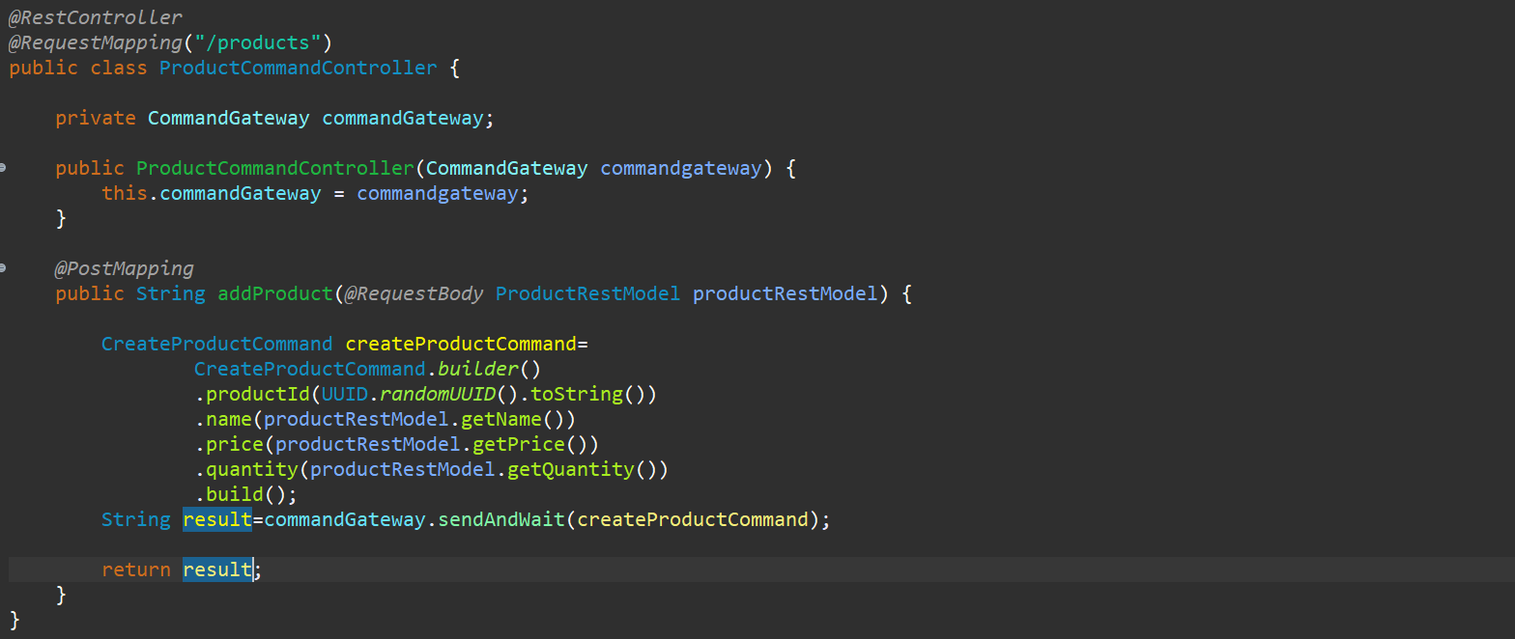

So, now your **Controller** is ready mean that particular **Controller** is sending one **Command** to your **CommandGateway**.

Now we need to have the Aggregate.



Now we need to have the Aggregate. Now if u go to the particular example. You have sent this particular command to this particular CommandGateway now you will be having one CommandHandler or Aggregate whatever you want to call. So, this particular Aggregate will handle this particular Command so let’s go and create this particular aggregate over here.

So go to the **command.api** and create one package called **aggregate**. And create one class called **ProductAggregate**. Let’s annotate this with @**Aggregate** and this will be the part of **AXON Framework**.

Now this Aggregate will also have the Payload data so go to Command and copy the particular fields.

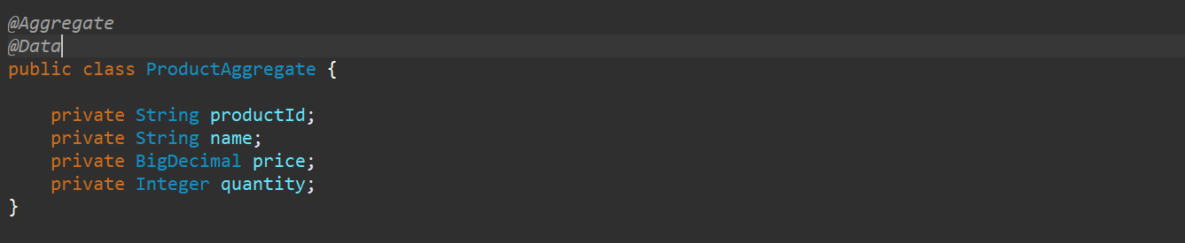

So, if you go to **CreateProductCommand** class you have mentioned this is a @**TargetAggregateIdentifier** but in your **ProductAggregate** you will define this as @**AggregateIdentifier**

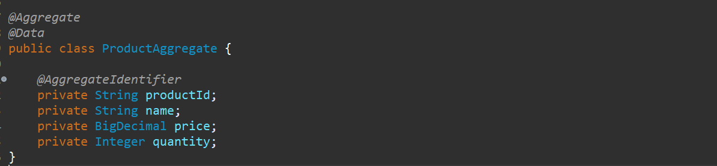

So, this particular product_id which is in aggregate and the product_id in your command will match and all the operation will be happening, and all the events will be happening for this particular entire data, and this would be identified using this product_id over here.

So, if you go to this particular **ProductAggregate**, so for this **ProductAggregate** to work you need to create a constructor and that constructor is taking a particular command over here. this particular constructor is taking or injecting a **CreateProductCommand** over here. and let’s define one default constructor and the constructor which is taking a **CreateProductCommand** as an input parameter**.** So, you can perform all the different validation over here and do what ever you want to do using this command and once it is done you need to create an **event** over here.

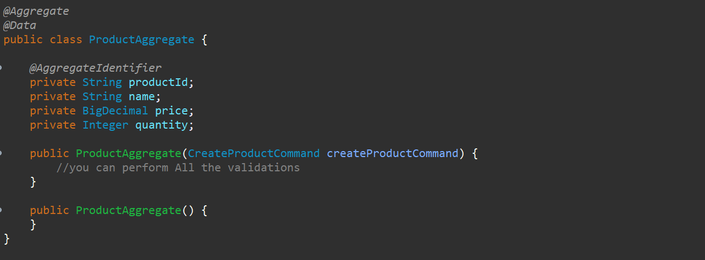

So, what event you are going to create over here is you can see that….



Once the particular Aggregate handling the particular **CreateProductCommand** this Aggregate will publish the event i.e **ProductCreatedEvent**. So, we need to create this particular event and we need to publish the event which will stored into our **EventStore.**

So, let’s create the **ProductCreatedEvent** first then we will publish it. So, in **commands.api** package let’s create a package called **events**. In this **events** package let’s create a class called **ProductCreatedEvent**, so this **ProductCreatedEvent** also should have a payload data.

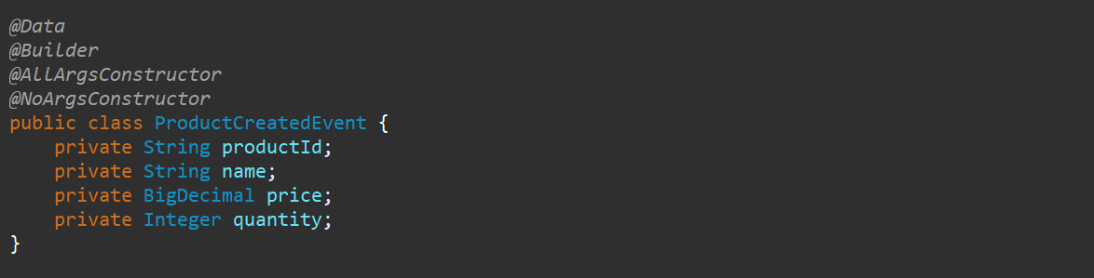

So, these all are the Lombok annotations which will be helpful to create an object of **ProductCreatedEvent**.

Now this particular Aggregate will publish this particular event. We need to go to the Aggregate we need to create the object of **ProductCreatedEvent,** and we need to publish it.



So. Let’s go to the Aggregate over here so, what you can do over here is either you can use Builder pattern to and take data from the **CreateProductCommand** over here and you can pass all those value to **ProductCreatedEvent**. Or you can use the **BeanUtils** over here to populate the fields over here.

As we have all the fields common over here so we will be using that. Either you can use builder pattern as well or you can use **BeanUtils** as well.

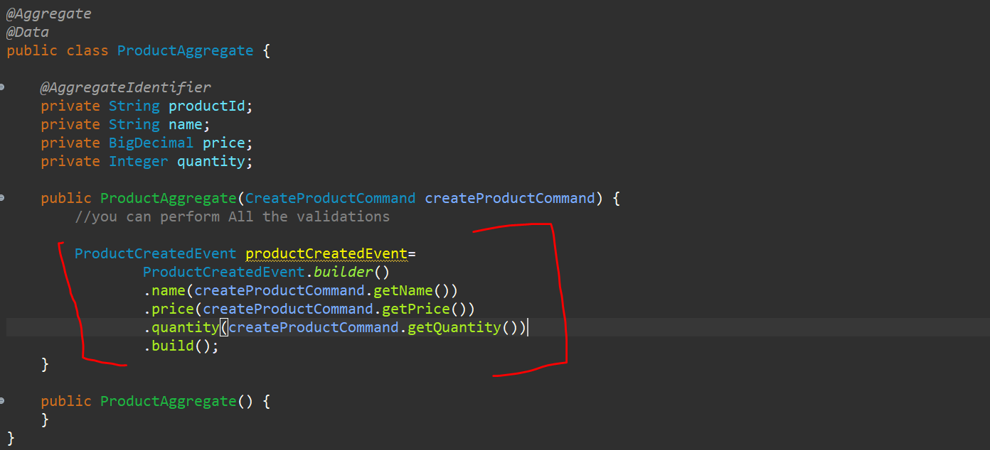

**OR (** we can use BeanUtils **)**

[**BeanUtils**](eclipse-javadoc:%E2%98%82=ProductService/C:%5C/Users%5C/kaukumar3%5C/.m2%5C/repository%5C/org%5C/springframework%5C/spring-beans%5C/5.3.23%5C/spring-beans-5.3.23.jar=/maven.pomderived=/true=/=/maven.groupId=/org.springframework=/=/maven.artifactId=/spring-beans=/=/maven.version=/5.3.23=/=/maven.scope=/compile=/=/maven.pomderived=/true=/%3Corg.springframework.beans(BeanUtils.class%E2%98%83BeanUtils)**.copyProperties(**[**Object**](eclipse-javadoc:%E2%98%82=ProductService/C:%5C/Users%5C/kaukumar3%5C/.m2%5C/repository%5C/org%5C/springframework%5C/spring-beans%5C/5.3.23%5C/spring-beans-5.3.23.jar=/maven.pomderived=/true=/=/maven.groupId=/org.springframework=/=/maven.artifactId=/spring-beans=/=/maven.version=/5.3.23=/=/maven.scope=/compile=/=/maven.pomderived=/true=/%3Corg.springframework.beans(BeanUtils.class%E2%98%83BeanUtils~copyProperties~Ljava.lang.Object;~Ljava.lang.Object;%E2%98%82java.lang.Object) **source,** [**Object**](eclipse-javadoc:%E2%98%82=ProductService/C:%5C/Users%5C/kaukumar3%5C/.m2%5C/repository%5C/org%5C/springframework%5C/spring-beans%5C/5.3.23%5C/spring-beans-5.3.23.jar=/maven.pomderived=/true=/=/maven.groupId=/org.springframework=/=/maven.artifactId=/spring-beans=/=/maven.version=/5.3.23=/=/maven.scope=/compile=/=/maven.pomderived=/true=/%3Corg.springframework.beans(BeanUtils.class%E2%98%83BeanUtils~copyProperties~Ljava.lang.Object;~Ljava.lang.Object;%E2%98%82java.lang.Object) **target)**



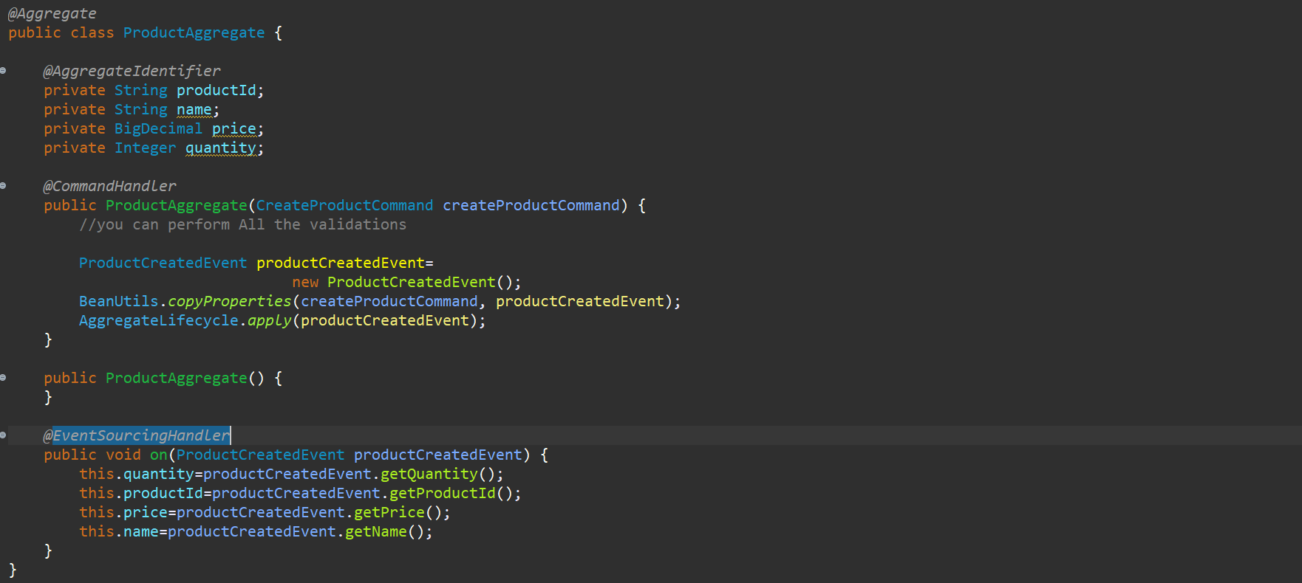

So, source is **CreateProductCommand,** and target is **ProductCreatedEvent**. So, all the values from this properties from this object will be copied to target object which is nothing but **ProductCreatedEvent.**

As we have same name available so it will copy all that values. Now what I want to do is I want to publish this event so I will use this **AggregateLifecycle.apply(productCreatedEvent)** and what is the payload the payload is productCreatedEvent so, this will publish the particular event.

Now for each and every Aggregate that you create, you want to use the **Event-Sourcing-Handler** over here to update your aggregate values so, whenever you want to handle any of the particular command in your command handler or the Aggregate or whenever you publish the event you need to update the Aggregate or state of the Aggregate. What are fields and what are the values has been changed.

So, whenever this particular **CreateProductCommand** has been handled over here and the ProductCreatedEvent has been created all this particular fields we are updating from this particular **createProductCommand**. so, we need to update the all the particular fields over here. so, whenever there is a new command i.e the **UpdateProductCommand** so at that time whatever the update is happening we need to update those values as well.

So, all this whenever we do that **Event-Sourcing-Update** that particular values will be stored in your event-sourcing data what we have shown earlier right what was the **Event-Sourcing**. So, in that way all those particular values will be stored in your **event-store** and whenever you want to replay it will be easier for the application to replay all those particular things. So, always remember that whenever there is a state change from the Aggregate over here whatever the aggregate you create. Whenever there is a state change update the values over here. so, for this particular **CommandHandler** whatever we are handling over here we are changing the states, so all these particular values were not there before now we are setting those particular values.

So, we will create one **Handler**, **Event-Sourcing-Handler** to set all these particular values.

So, I will just create one Handler, on what event it should occur is **ProductCreatedEvent.** I should annotate with @**EventSourcingHandler** over here. so, whenever this particular ProductCreatedEvent will occur this **Event-Sourcing-Handler** will be executed to handle the **Event-Sourcing** data. so, what I want to update is I want to update all the fields.

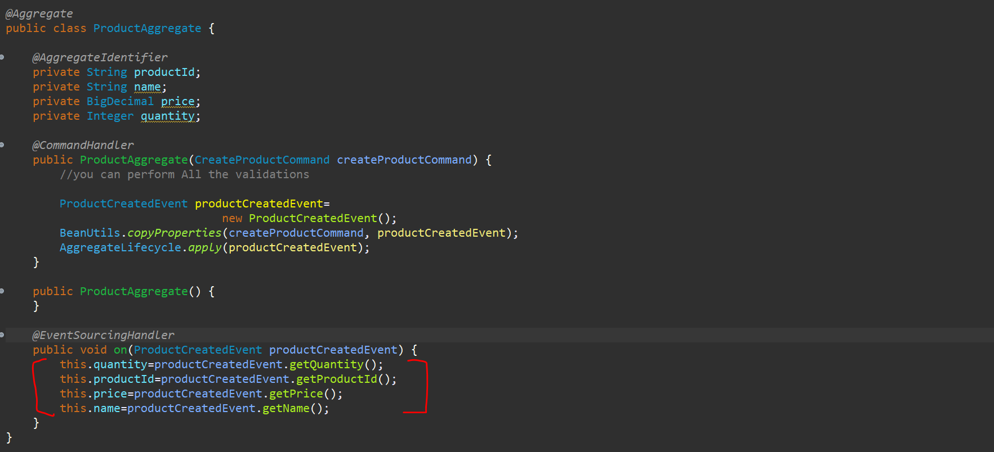

So, this is your **Event-Sourcing-Handler**. So, make sure that whenever you are handling the command you should be having the **Event Sourcing Handler** to handle the state of that particular command. so, every time this 2 will be go hand in hand always.

So, now for this particular **ProductAggregate**, in this particular **ProductAggregate** only if you want to handle the different command that you have then you don’t have to create the constructor you can create the method also that u can implement because it only requires one particular constructor with the one particular command to register this. After that you can create a simple method i.e public void handle and handle this particular command (**CreateProductCommand**).



So, now your Aggregate is also created. Now we have already published the event **ProductCreatedEvent** to our **EventStore**. Now we need to have the **EventHandler** that will handle the events. ok, that will listen the events from the particular **EventStore,** and it will save the data to the **Repository**.

So, I need to have the **EventHandler**. So, in our **events** package I will create the **ProductEventsHandler,** and I will annotate this with **@Component** so it would be in our SPRING radar. Now this particular **ProductEventsHandler** will be handling the **ProductCreatedEvent** that is been published from this particular **Aggregate** which is **ProductAggregate**.

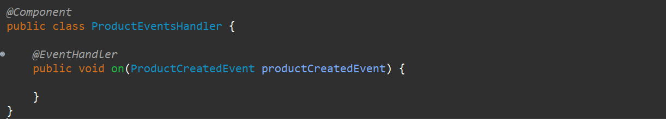

So, this particular **ProductCreatedEvent** has been published we need to handle it in **ProductEventsHandler** over here. and we need to handle that method with @**EventHandler** from **AXON Server**. Now we need to handle the event over here. What we need to do is whatever the data I mean whatever the payload we are getting we need to save in our database. so, I need to have the Entity and I need to have the Repository for it.

So, in **command.api** package we need to create 1 more package **data**. **data** package will contain the Entity name **Product** which contains all fields which is there in command like (productId as PK, name, price and quantity) and Repository name as **ProductRepository**.

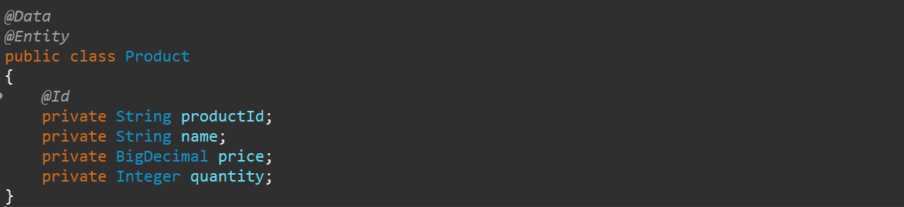

Now for this particular Entity I need to create the Repository called **ProductRepository**.



Now I want to inject this particular repository in my EventHandler, and I can save the data. now let me inject repository in handler using the constructor. So now I can create the object of a product in the **EventHandler,** and I am going to use BeanUtils to create object from event to product and save the product. **So, that’s it the entire flow is done now…….**

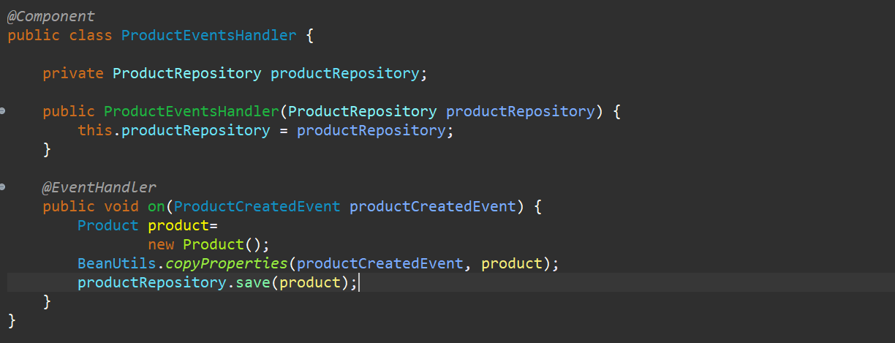

So, we just created the entire flow over here.



**Complete flow for Event-Driven-Architecture for CQRS Command API Flow-🡪**

We created the Controller which will handle the **/products** for the **POST** method over here. From this **Controller** we are sending the **CreateProductCommand** to the **CommandGateway** and whatever the data or whatever the command we are sending to the **CommandGateway** we are handling using the aggregate over here. make sure **Aggregate** is your **CommandHandler** and **Projection** is your **QueryHandler**. So we created this particular **Aggregate** and this particular **Aggregate** is handling this particular **command** and whatever the operations or whatever the business logic that you have you can use this particular business logic there and you can publish the event over here. we are publishing the **ProductCreatedEvent,** and that particular event is been stored in **EventStore**. After that we created the **EventHandler** that is the **ProductEventsHandler** and that particularis listeningthe particular **ProductCreatedEvent**. Whenever this particular event occurs, we are using the repository to store the data in our database.



So, here you can see whatever the standard flow means standard structure it was only 3 layers we were using now we have converted entirely into **event-driven-architecture** and also, we are using CQRS architecture to store all the data over here.

Now let’s go and test it out---

So let me just start the server on port 8081.

And let’s run the axon server on port 8024

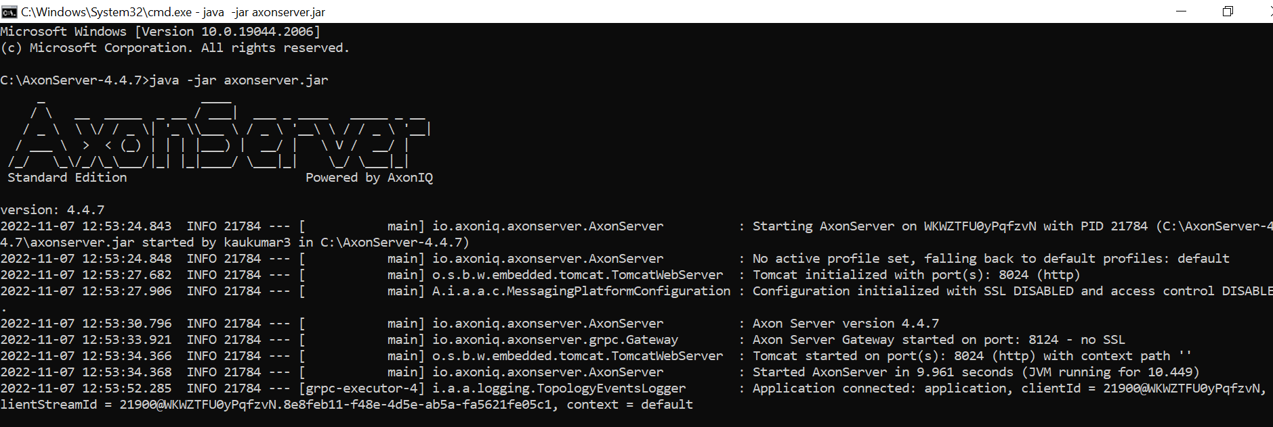

<http://localhost:8024/>

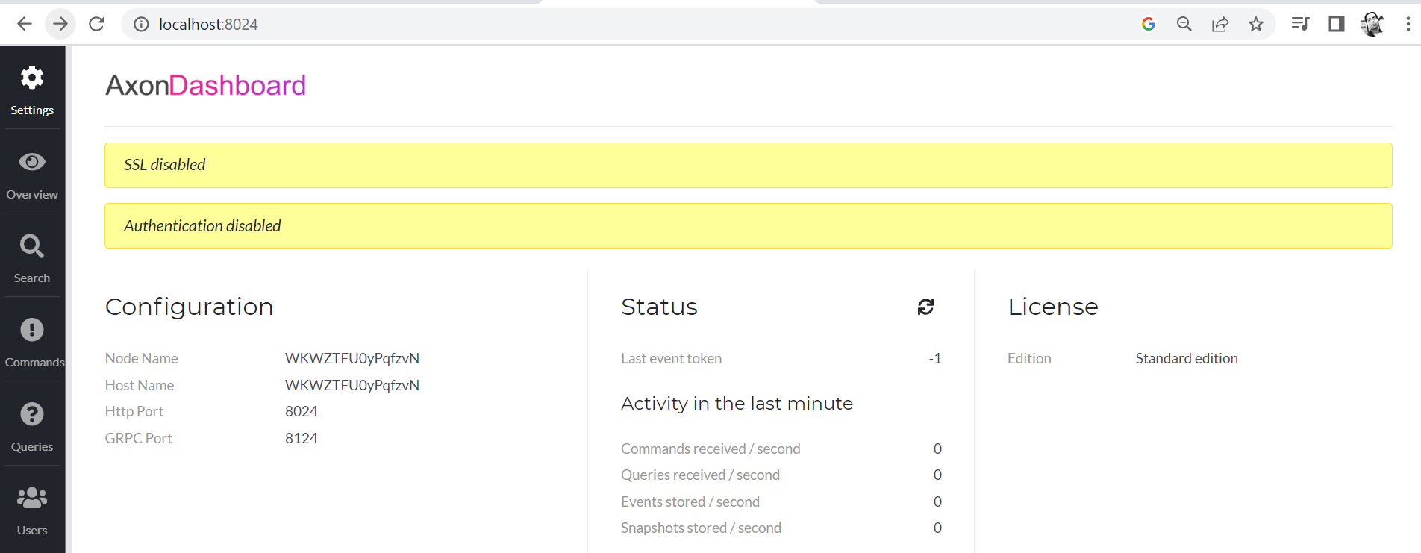

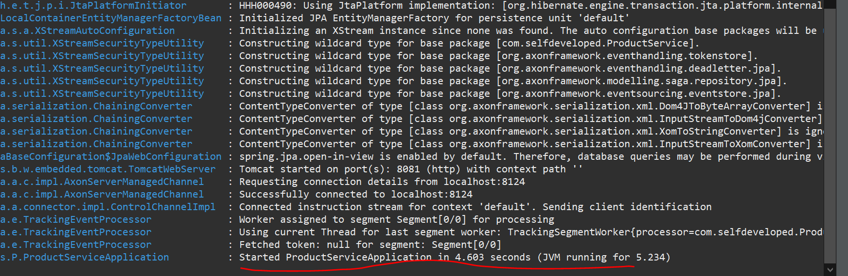

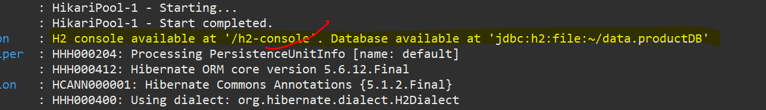

Now let’s open the h2-console database…

<http://localhost:8081/h2-console>

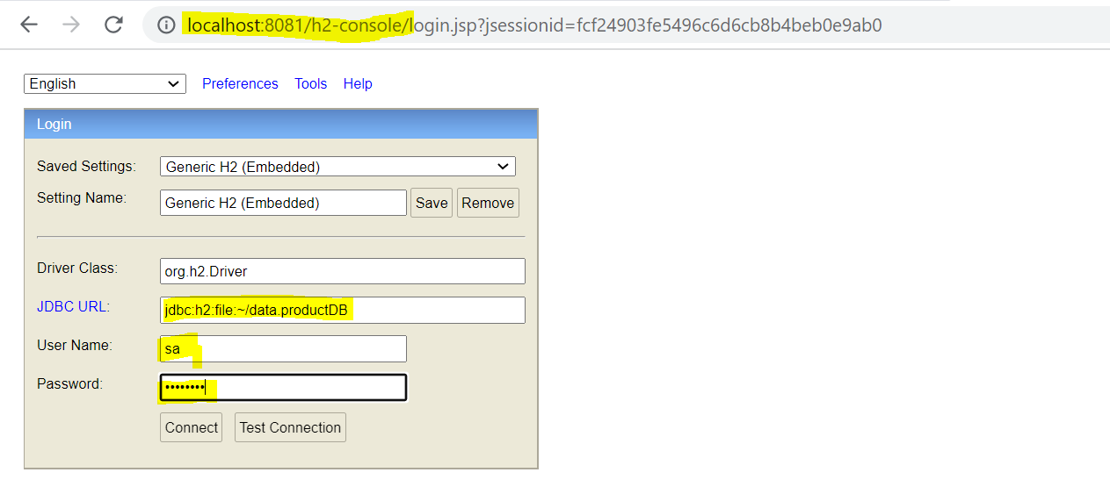

And our jdbc URL, username and password is same as what we configured in properties file.

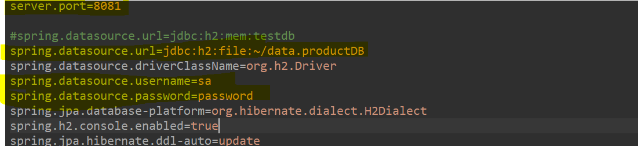

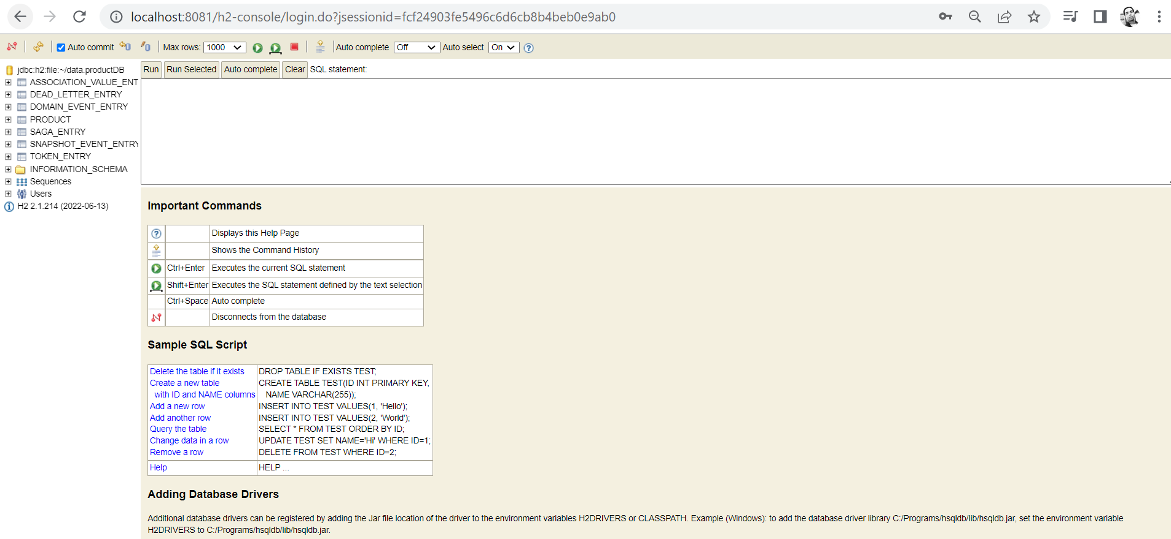

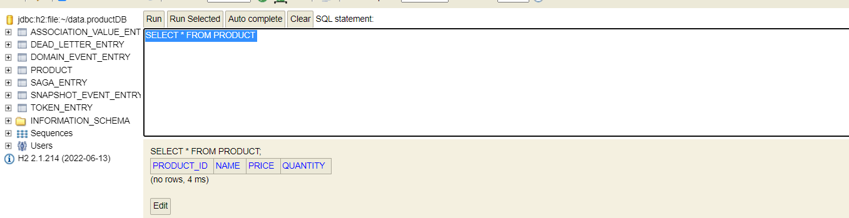

So, there are no products available. There are different tables related to AXON Server.

**Now if you go to the axon-server overview there is 1 application got started and 1 instance got connected to the axon-server itself.**

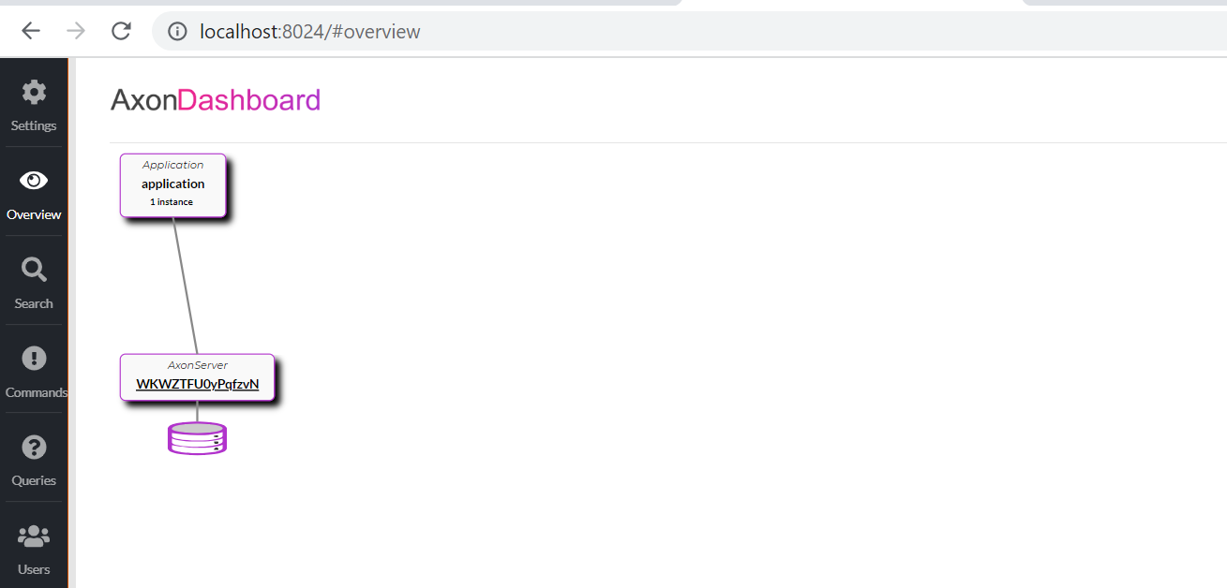

Now u might get wondering how this is directly got connected to the axon server. Because we have added axon-started to the axon-framework as a dependency in our application so, there is a default configuration is available for remote application.

Now just go to the postman and hit the particular url what we have created.

<http://localhost:8081/products/>

**{**

**"name":"Book",**

**"price":"872",**

**"quantity":"1"**

**}**

So, this is the one of the Product which I want to save.

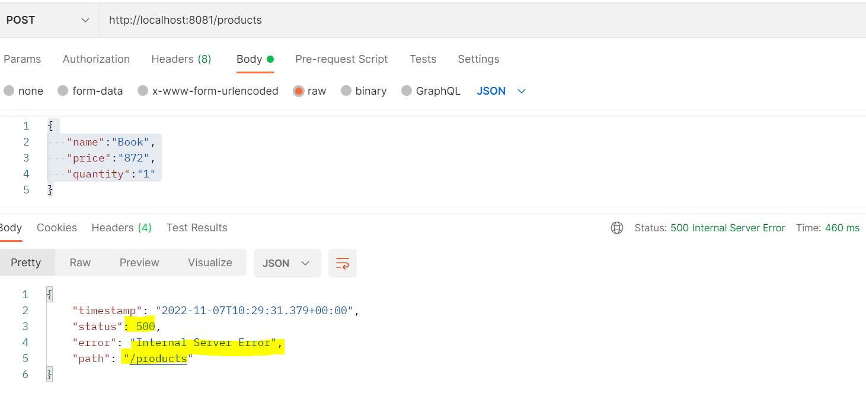

We are getting Internal Server Error. The error is: No Handler for command - **CreateProductCommand**

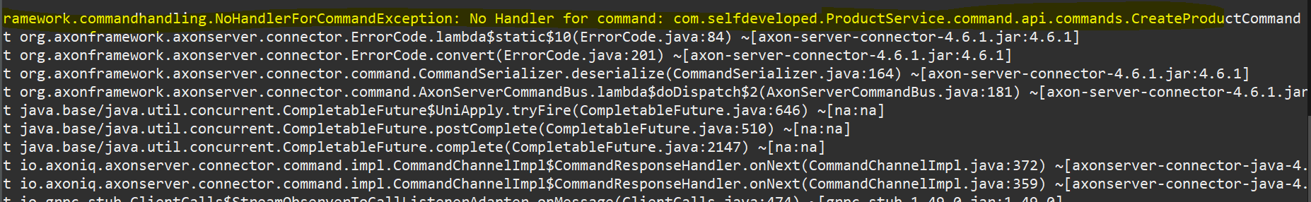

So, let’s check that if we will go to Aggregate

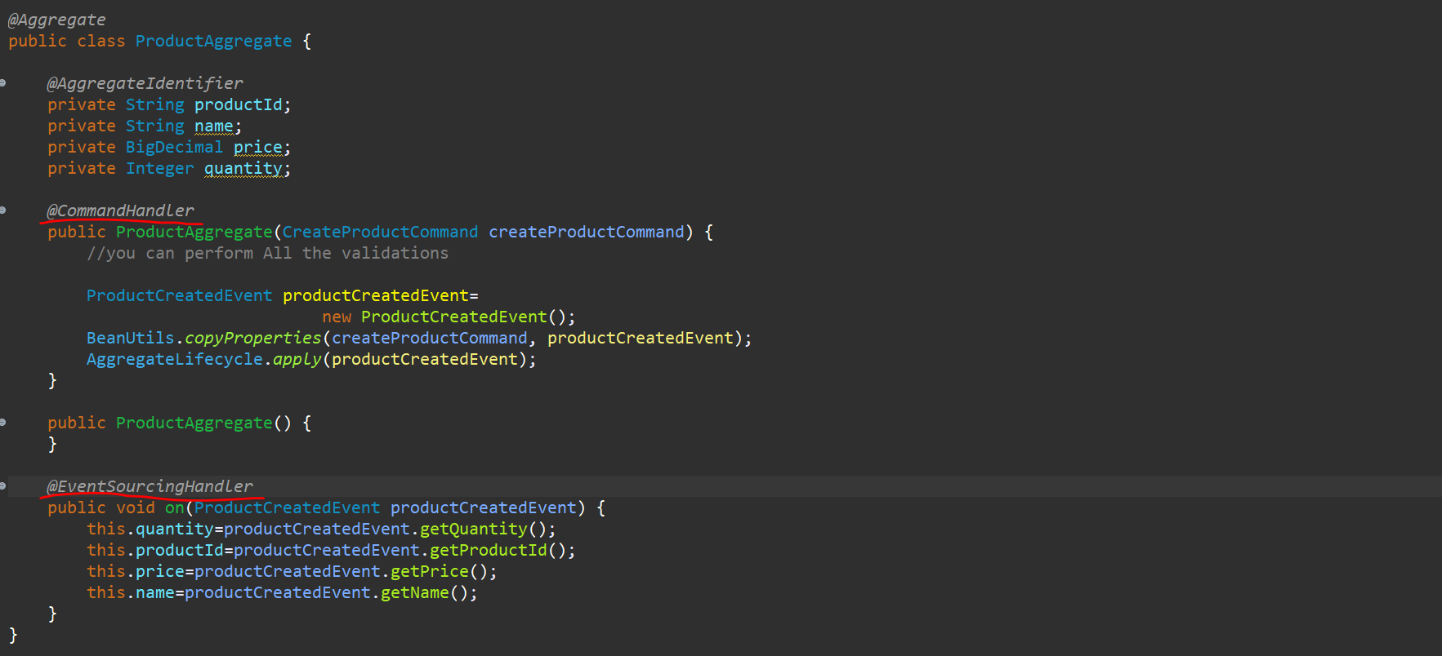

So, this is the CreateProductCommand **Handler,** and we forget to add the **@CommandHandler** annotation here. so, if we restart the server and if we go to the Axon Server now, we should be able to see the command. now we are not getting any error as well.

Now let’s go to the postman and let’s hit and send it again… so here you can see that we got the Status: 200 success and the id available.

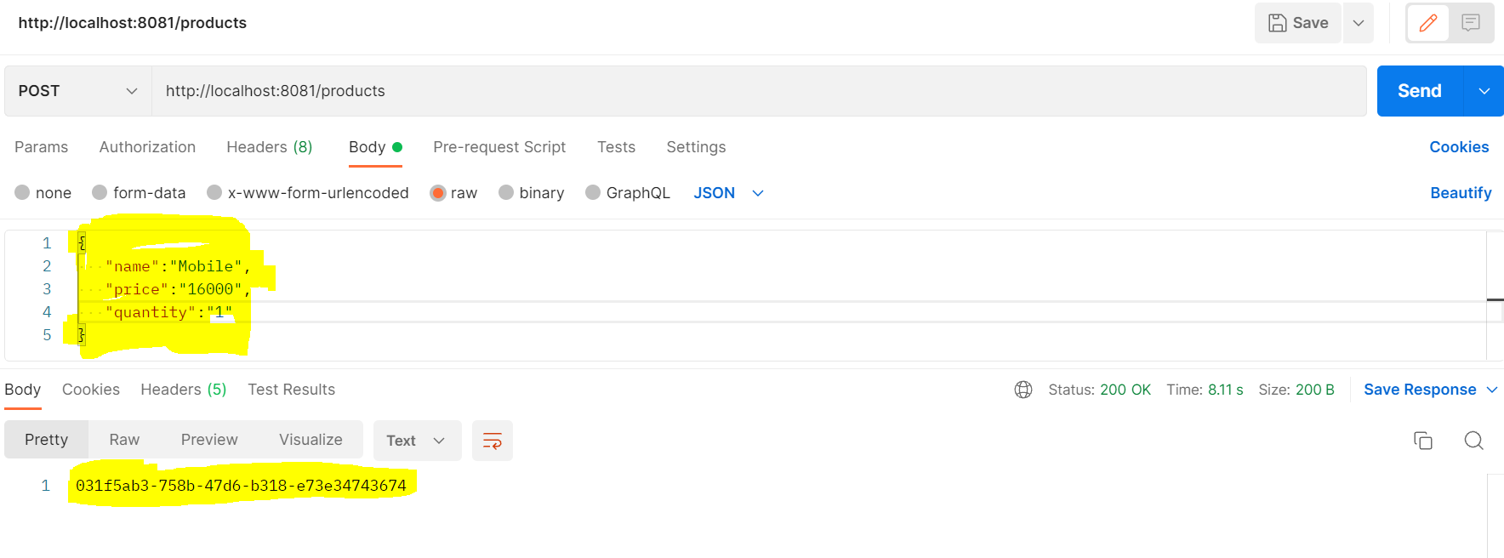

Now let’s see what happened over here. if you go to the AXON Server over here if you go to the search . click on about the query language.

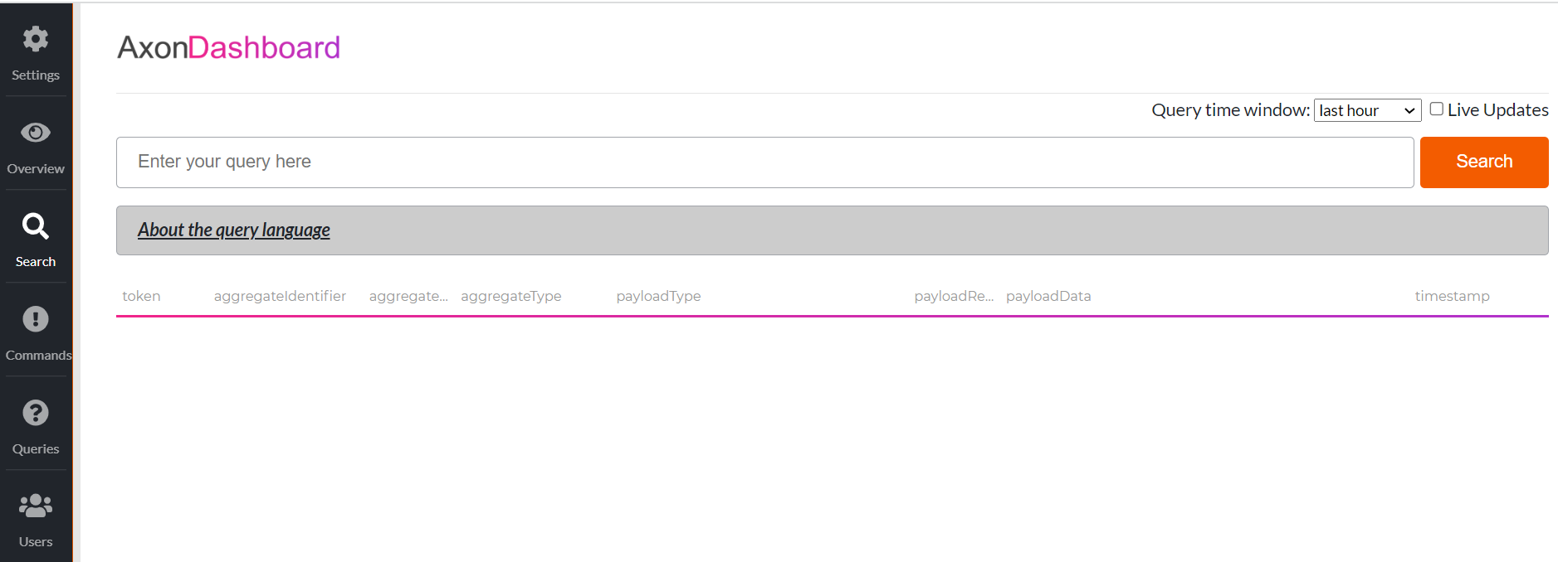

**About the query language**

**You can query the event store through this page. The query operates on a stream of events, where you can define filters and projections to obtain the results that you want.**

* **When you perform a search without any query it returns 1000 events.**
* **The event stream contains the following fields:**
* **token**
* **aggregateIdentifier**
* **aggregateSequenceNumber**
* **aggregateType**
* **payloadType**
* **payloadRevision**
* **payloadData**
* **timestamp**

### **Filtering**

* **Filtering lets you reduce the events you see, so you get only those events that you want. A simple filter is to find all the events for a specific aggregate:**
* **aggregateIdentifier = "beff70ef-3160-499b-8409-5bd5646f52f3"**
* **You can also filter based on a partial value, for instance a string within the payloadData:**
* **payloadData contains "ACME"**
* **And, of course, you can combine these filters with AND or OR:**
* **aggregateIdentifier = "beff70ef-3160-499b-8409-5bd5646f52f3" and payloadData contains "ACME"**

### **Projections**

* **You can select the fields, perform operations on the fields and perform grouping functions. For instance, you can perform a query that returns the number of events grouped by the payloadType:**
* **groupby(payloadType, count())**
* **You can also select a number of fields and perform operations on them:**
* **select(aggregateType, payloadType, formatDate(timestamp, "yyyy/MM/dd HH:MM") as time)**
* **Combining filters and projections is also possible, by creating a pipeline of conditions, e.g.:**
* **aggregateSequenceNumber > 50 | groupby(payloadType, count())**

### **Limiting results**

* **Filtering on recent events is done by adding a time constraint to the query chain. An example:**
* **aggregateSequenceNumber > 50 | last 4 hours**

### **Functions**

* **For more information on all supported functions check the reference guide.**

So, in above you can see that this way you can get the details over here. with the **aggregateIdentifier** let’s copy this paster that information in search bar and let’s change the identifier which we got from postman and search.

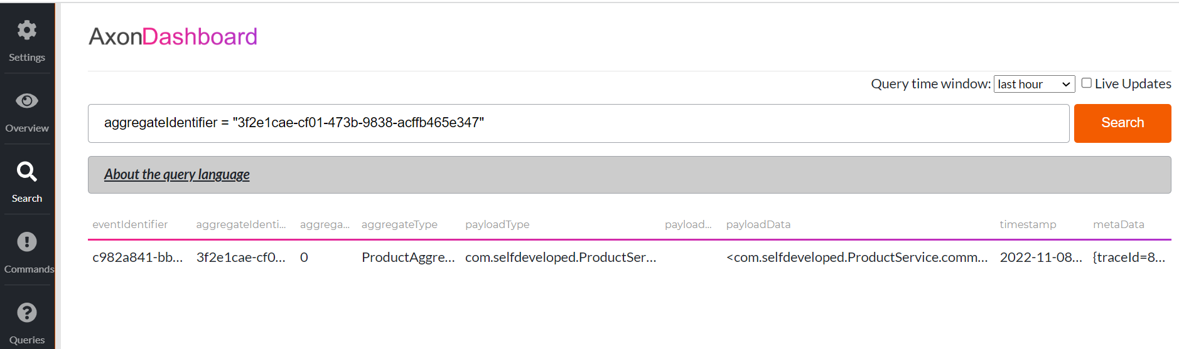

Here you can see that this is the particular event identifier event over here. so here you can see that this is the particular eventIdentifier, aggregateIdentifier, aggregateType and the payload as well.

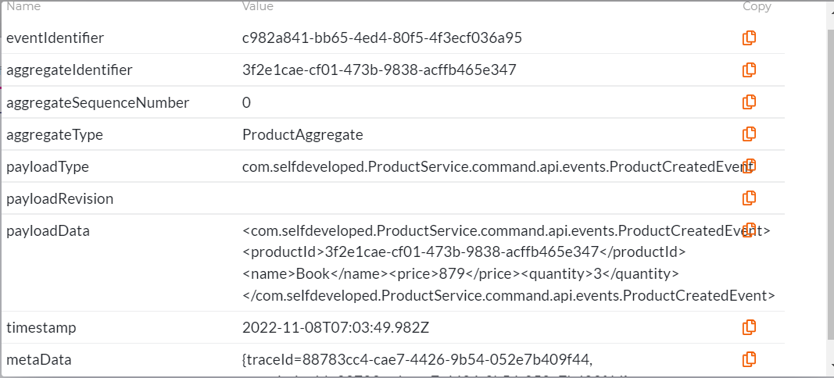

So here you can see that this is the payload information, which is in XML format, but you can change it to JSON as well through Axon configuration.

**<com.selfdeveloped.ProductService.command.api.events.ProductCreatedEvent>**

**<productId>3f2e1cae-cf01-473b9838-acffb465e347</productId>**

**<name>Book</name>**

**<price>879</price>**

**<quantity>3</quantity>**

**</com.selfdeveloped.ProductService.command.api.events.ProductCreatedEvent>**

If we go to the database, we can see data in H2 Console---

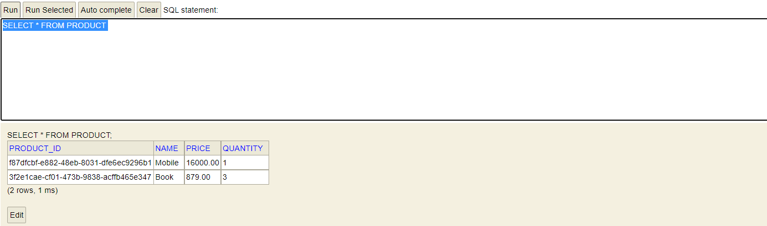

We can see that the entire operation completed successfully. We are able to create a command so this particular entire flow this one is completed successfully.



We have the controller. We have created the command. we sent the command to CommandGateway. We created the Aggregate that is handling the particular Command and we are creating the event from it and publishing that event into EventStore, and we saw the event here as well in Axon Server in the Dashboard.

Now this is about the Creating the Commands. The same way we can create the command for updating the data, deleting the data and everything over here. so, now you can go and try different events and commands as well. Now the 2nd part which is important is **Query API**. So, let’s go and Implement the Query API to fetch the data from the stored data over here. Ideally you might be creating the different services altogether for the Command part and Query part but in this example for simplicity let’s create in the same way in the same particular example like **command.api** we have created the **query.api** and under that we will create different packages and classes.

**CQRS Query API Flow**

First let’s create the Controller under **query.api** package. Let’s create a controller class with name **ProductQueryController** and it will give List of data wring whatever it stored in database. so, we need a List of **ProductRestModel.** As you can see, I am using this ProductRestModel from the Command API. Ideally you should not use in that way you should create a **core-libraries** for both of it and you should use both into the particular example. So, you can create a **core-api** and where you can use common classes and common packages.

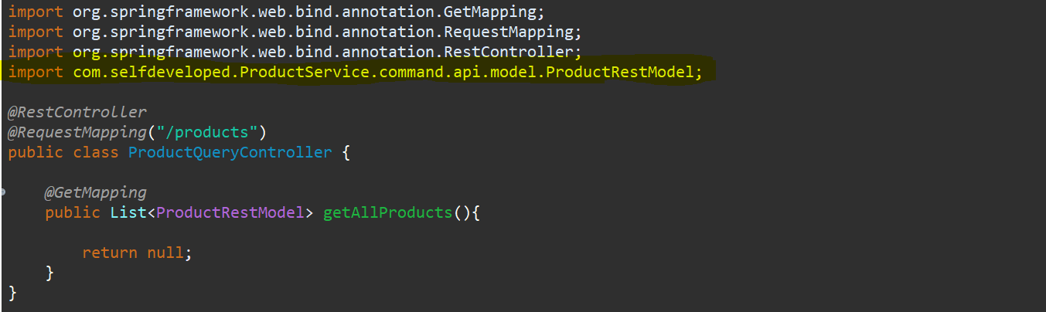

So here what we need to do In **Command API** we have created the **CommandGateway** to send our command but for this particular **Query API** we need a object of **QueryGateway** and inject QueryGateway using constructor injection.

Now we can understand easily so in the **Command API** you created the **command** but in **Query API** you will create the queries to fetch the data. In command you are telling system to do some command some operations and queries means you want to fetch any data. for the **Command** you will be having the **Aggregate** and for **Query** you will be having the **Projection**. both are same **CommandHandler** and **QueryHandler** so u can name it either way.

So, our **Controller** is created let’s create the **query.** In **query.api** let’s create the **queries** package.

We have created the **GetProductQuery,** or you can create FindProductQuery as well. Now I need to use **QueryGateway** to query this particular query.so I ll use **queryGateway.query()** where we can define a simple query and we define what is our Response Type format I want the data back so **ResponseTypes.multipleInstancesOf()** so as I want List over here so multiple instance of **ProductRestModel**. So, I am just passing the query to QueryGateway and getting the response back as well. So, I am defining the return type will be multiple instances of ProductRestModel. And we will give the reference as List of ProductRestModel. Since this is a Completable Future so I will use join method to wait until I get the data here.

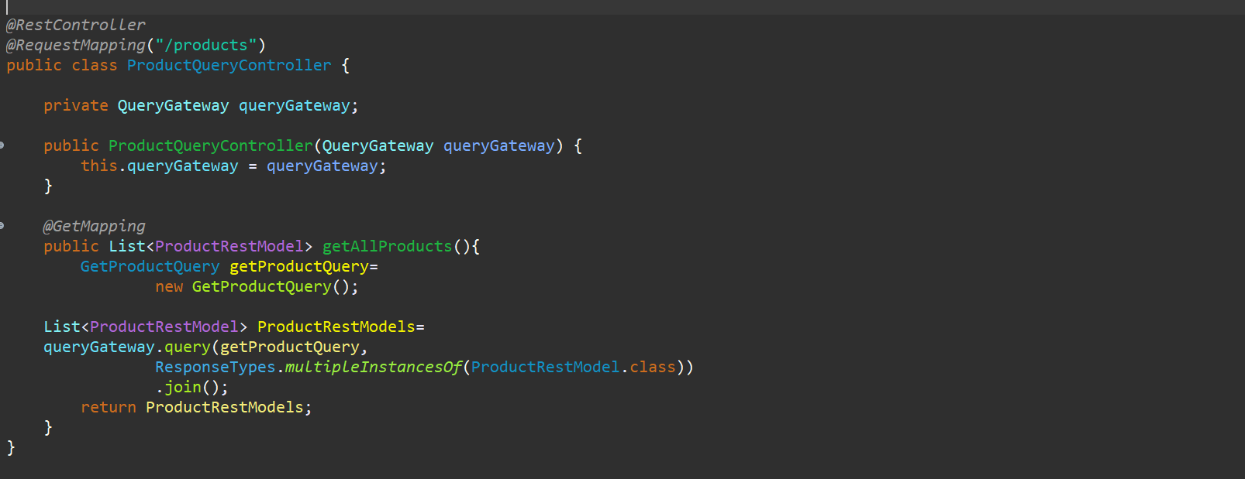

So, my Query is created now I need to handle this query. So, let’s go and create the **Projection** to handle this query. So, in **query.api** let’s create one package **projection** and let’s create one class as a **ProductProjection**. I will annotate this with @**Component.**

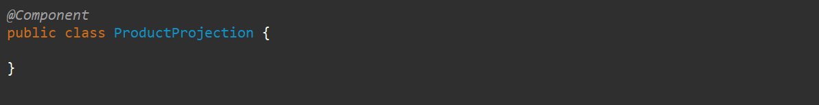

Now from here also from particular this projection you can handle this particular query and you can create the event and that event will send the data back to you that also you can create or from this particular projection you can pass the data back as well. So, from here I will directly pass the data back. So, to get the data back I need the Repository.

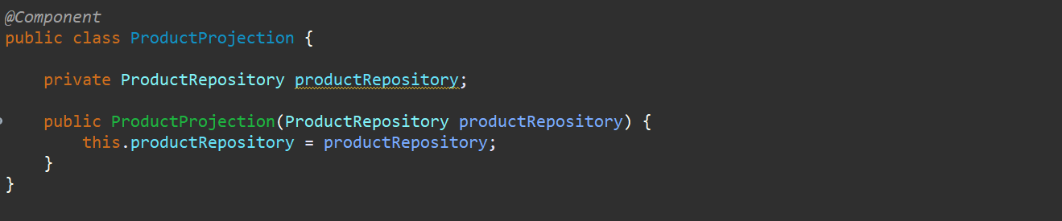

Now I need to handle the query over here. for command you were using the CommandHandler but for query you will be using the QueryHandler

**List<Product> products=productRepository.findAll();**

Will return the list of products available but we want the List of **ProductRestModel**. So, let’s convert from **Product** to **ProductRestModel.**

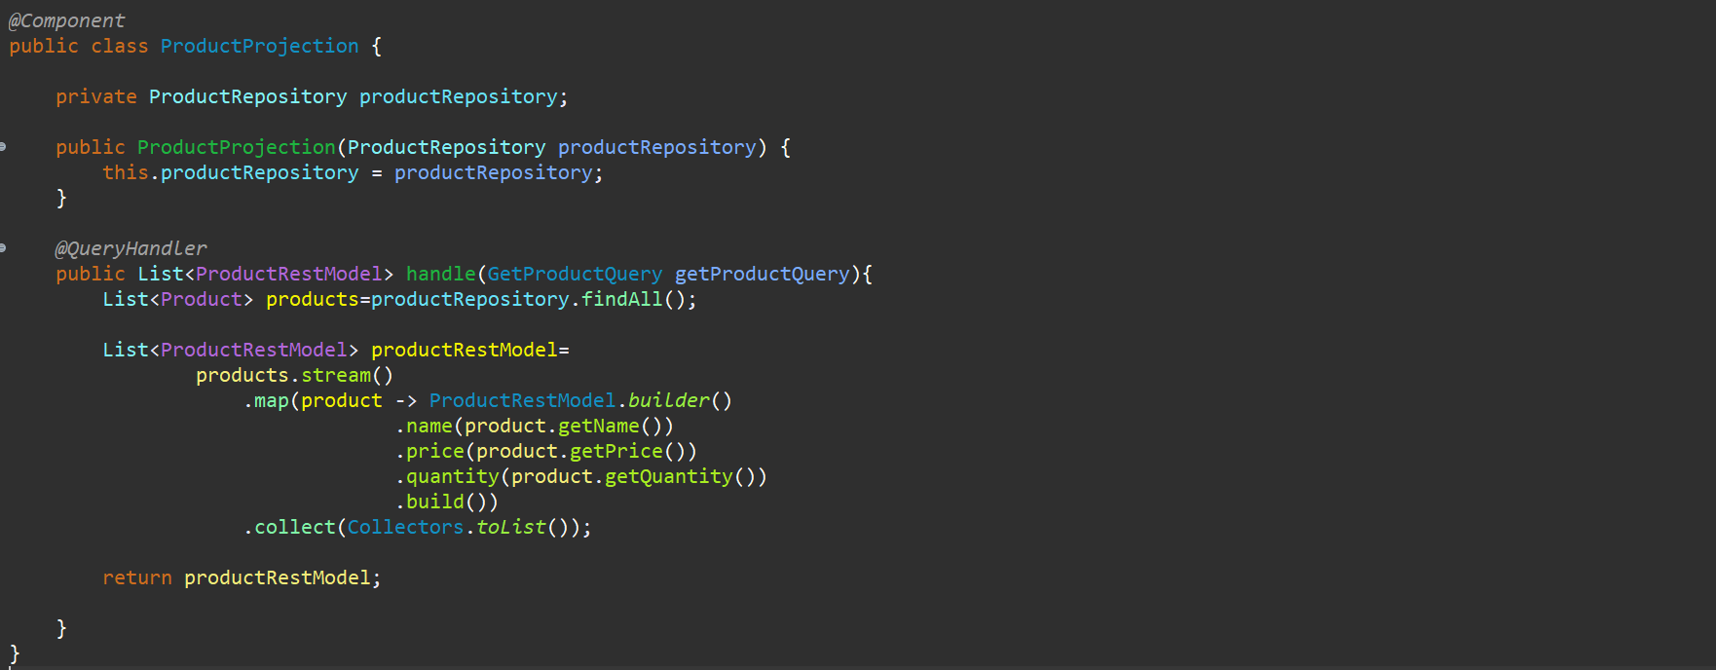



It’s the same flow we have created over here. we have created the controller that will handle the api request with /**products** for the **GET** method and we have created the query instead of command named as **CreateProductQuery** and that particular query will be handled by the **Projection**. Now let’s run the application and see it.

**So, Instead of POST let’s create a GET request in Postman –**

**GET :** [**http://localhost:8081/products**](http://localhost:8081/products)

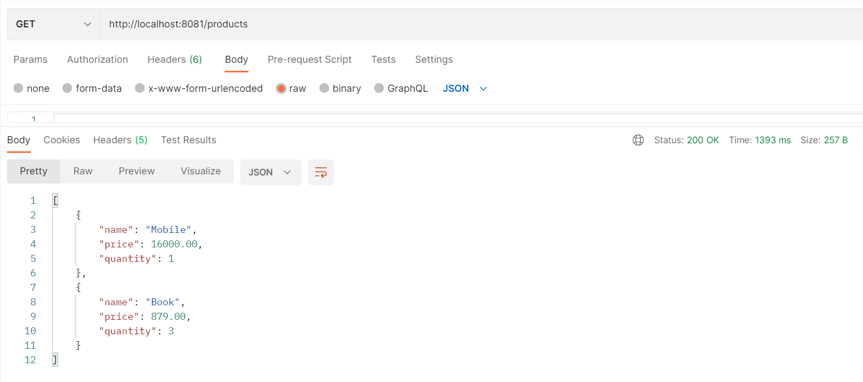

So, we are getting the list of products as a response. So, let me add a new product and try to get the list of products.

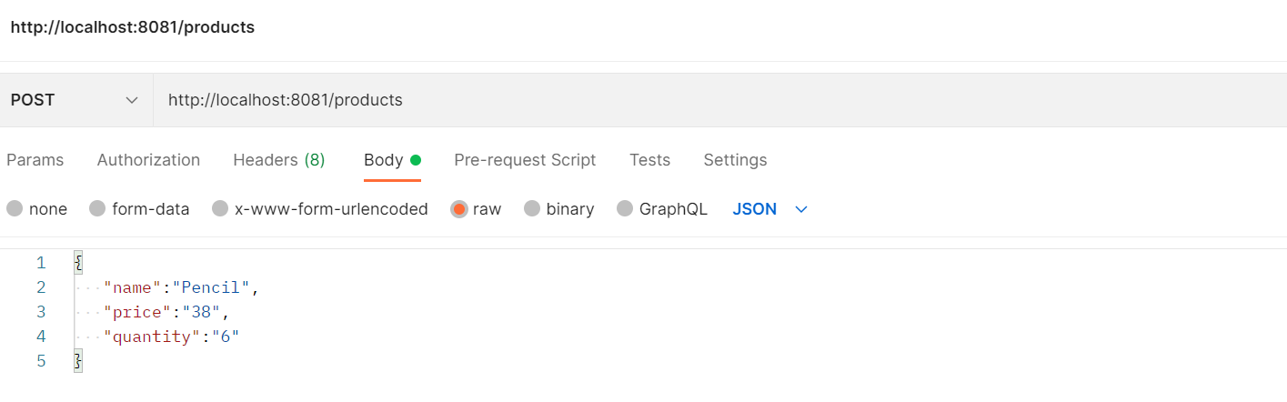

------------------------------------------------------------------------------------------------------------------------------------------

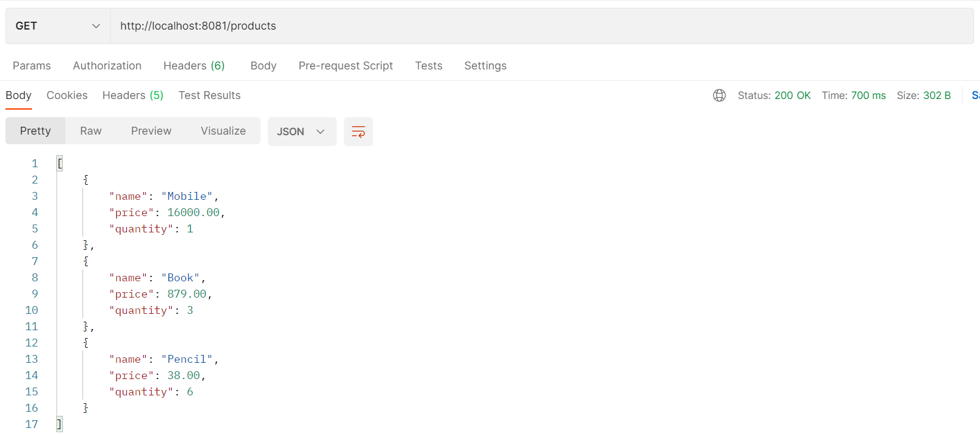

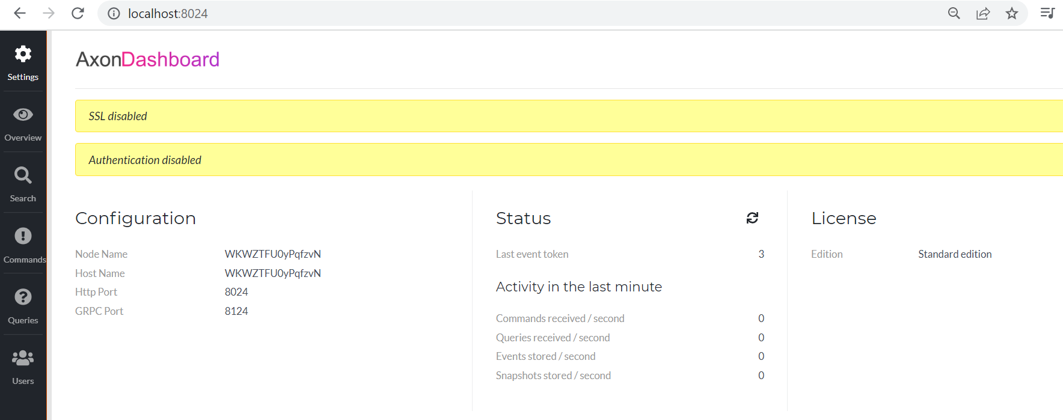

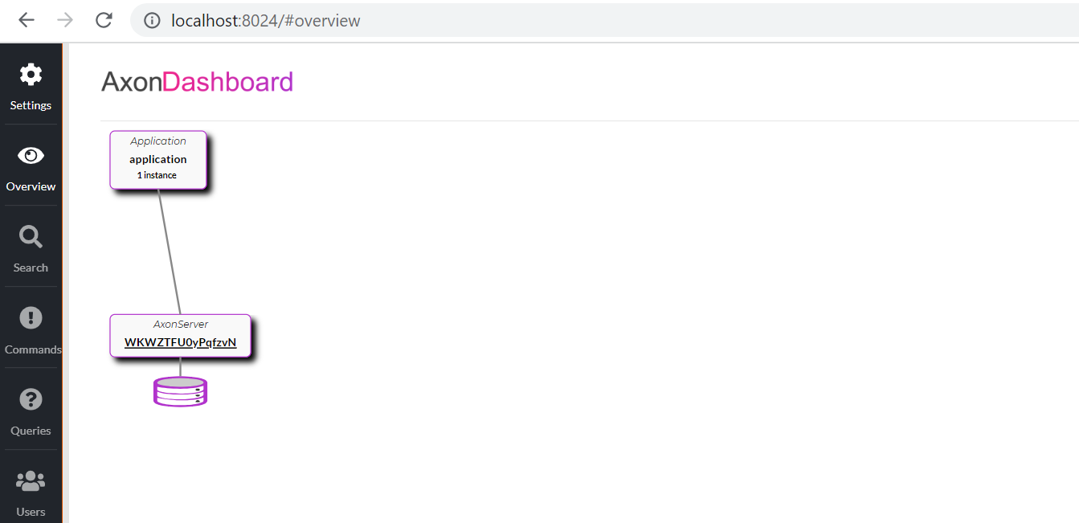

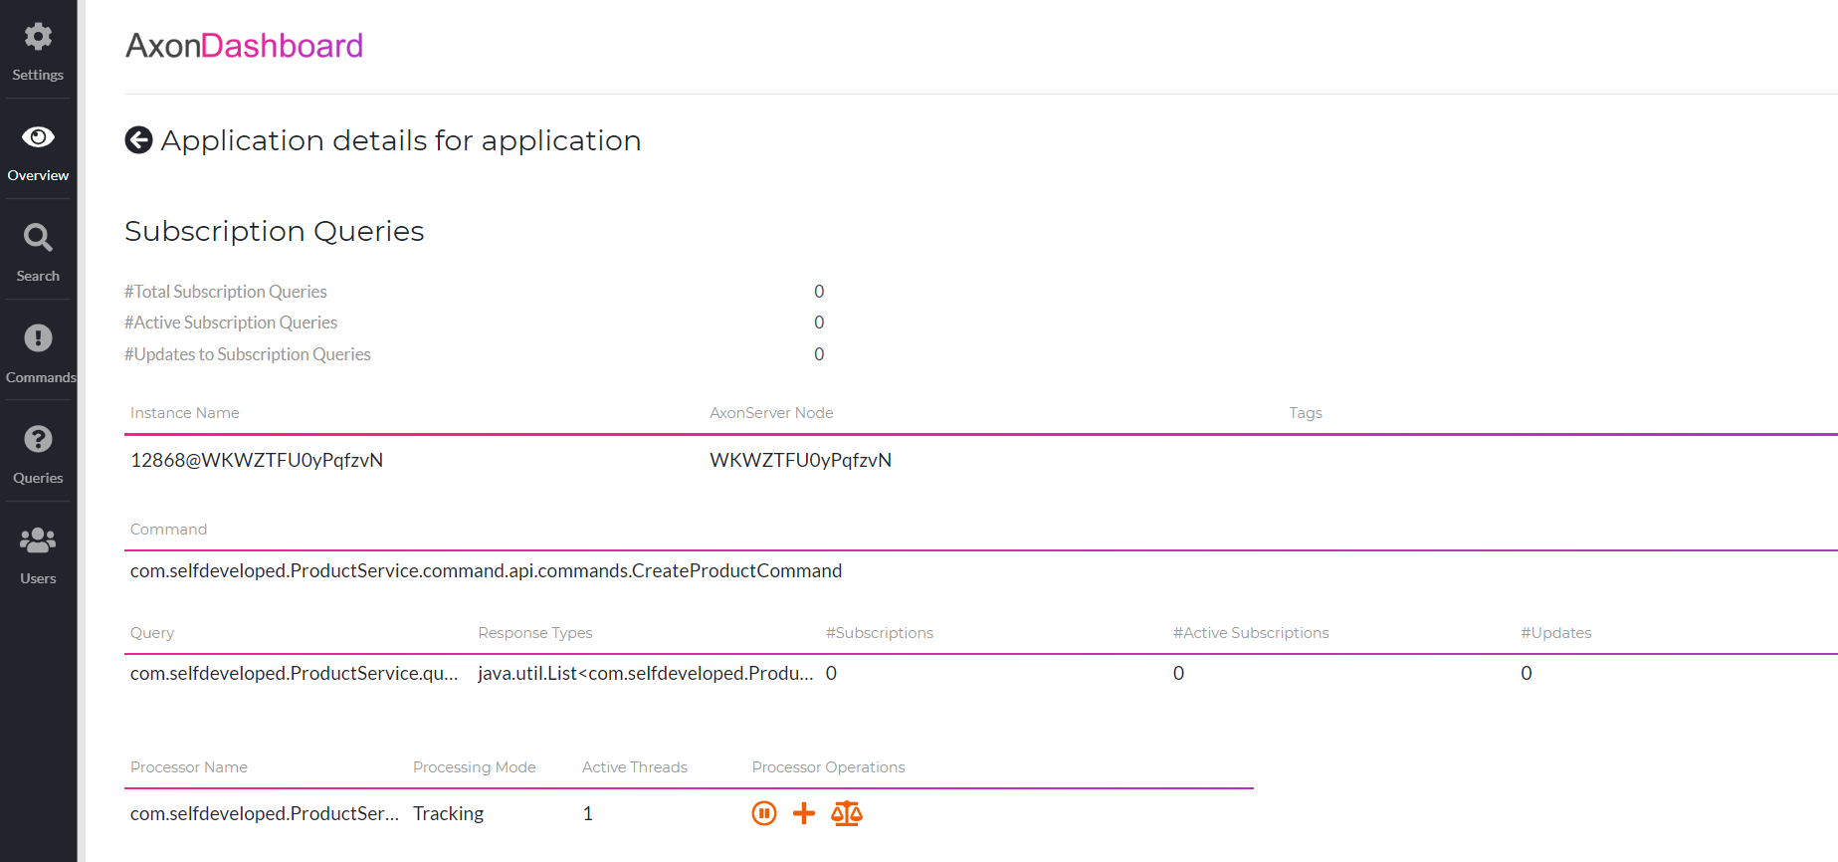

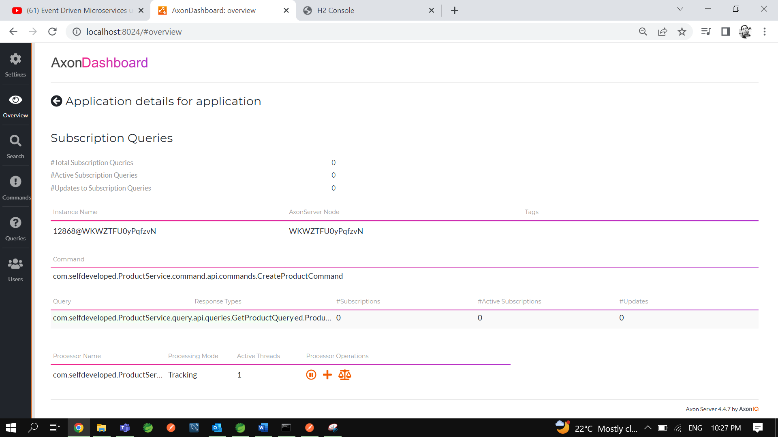

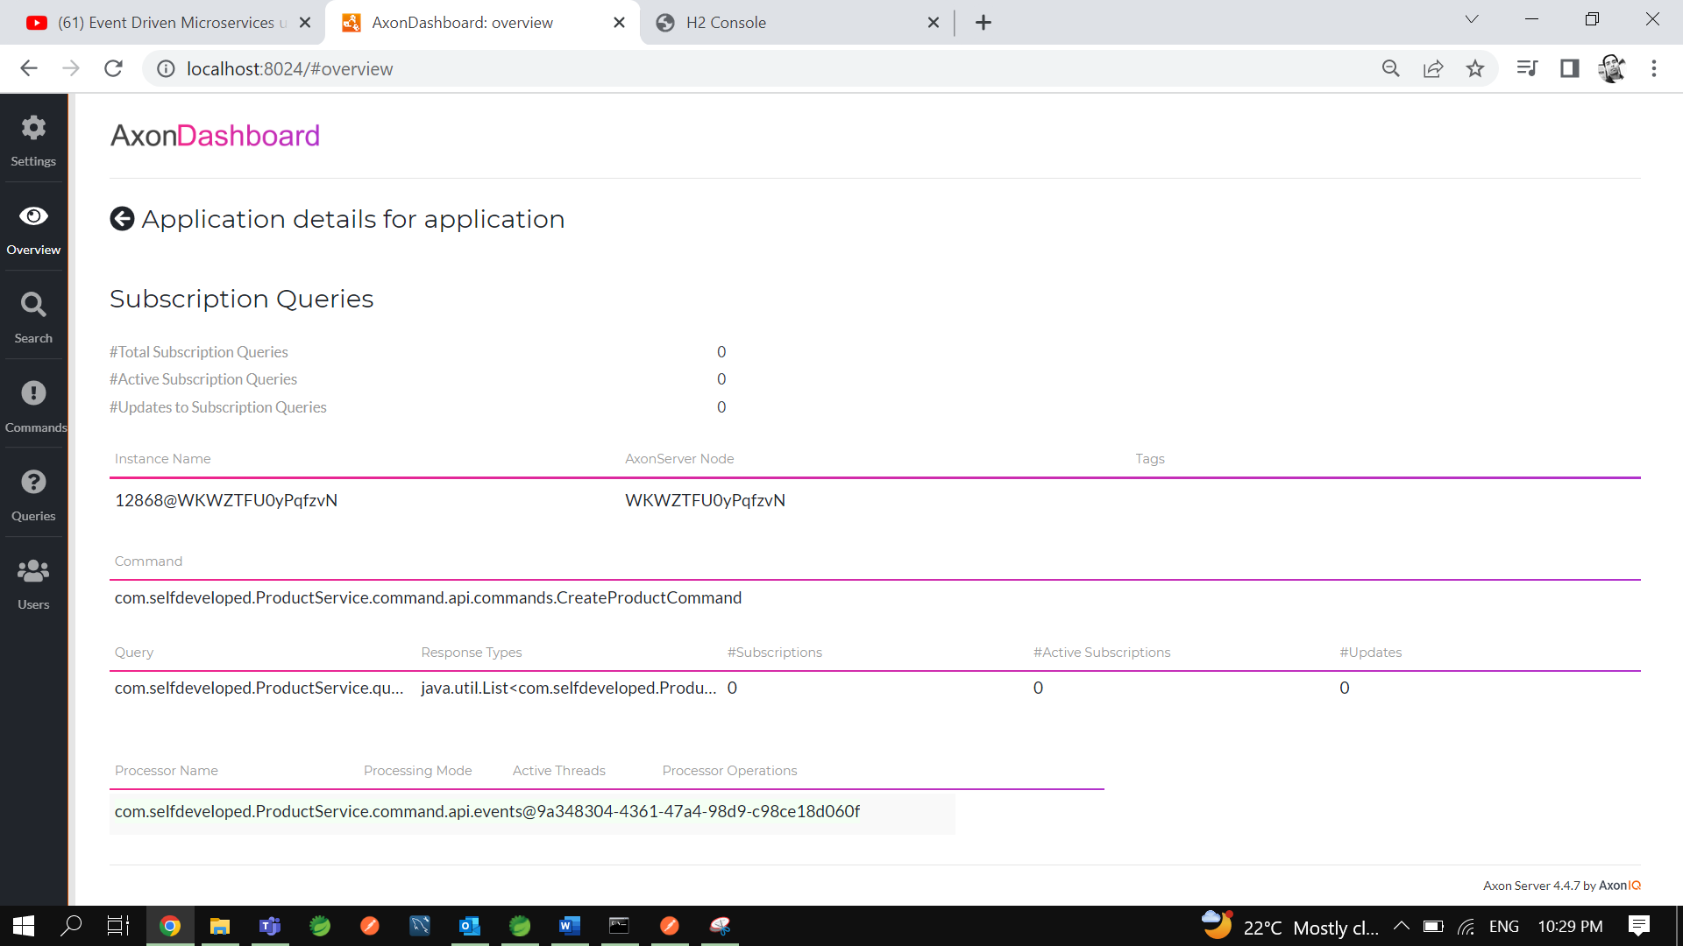

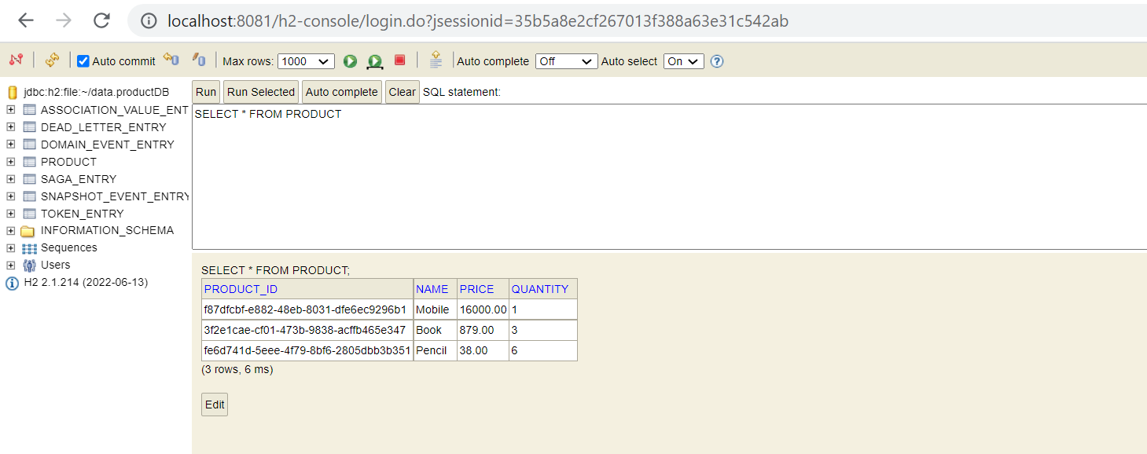

Let’s filter Axon server using query using all 3 different **aggregateIdentifier**.

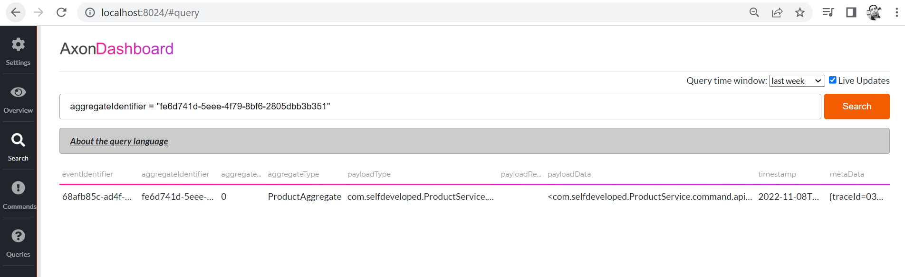

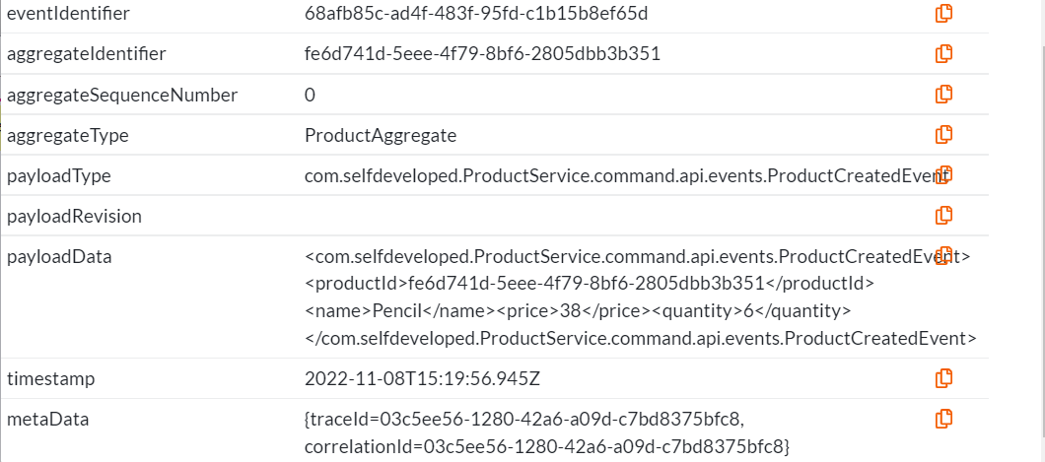

------------------------------------------------------------------------------------------------------------------------------------------

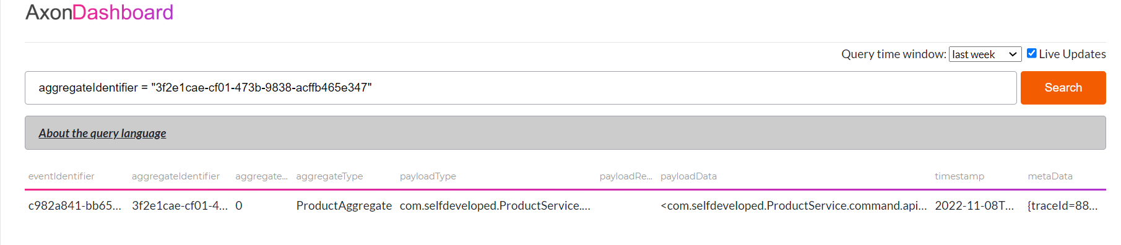

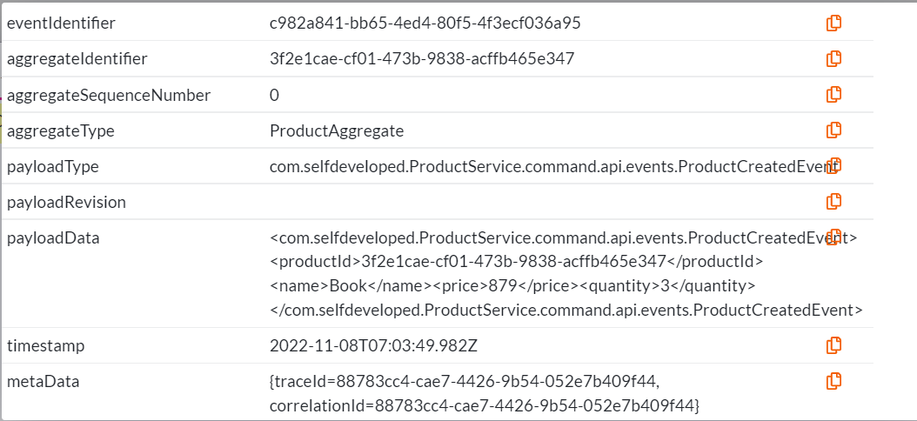

------------------------------------------------------------------------------------------------------------------------------------------

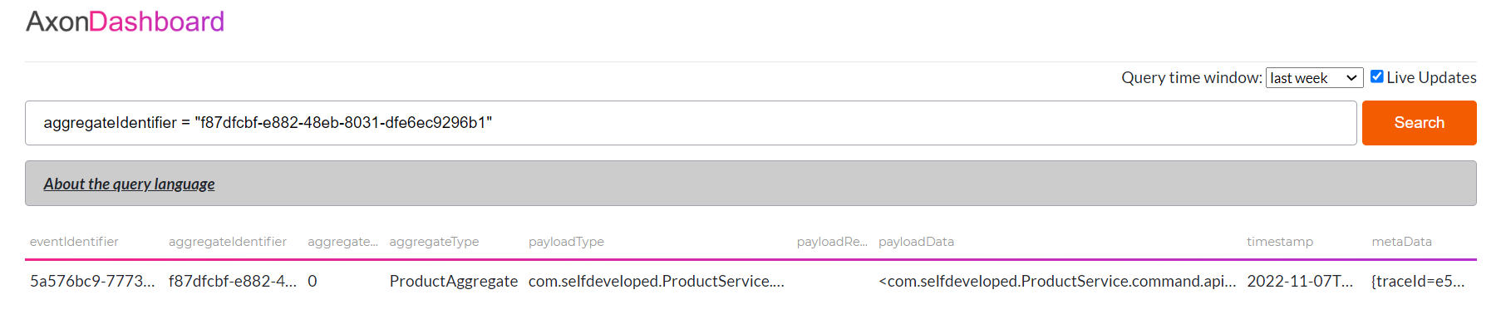

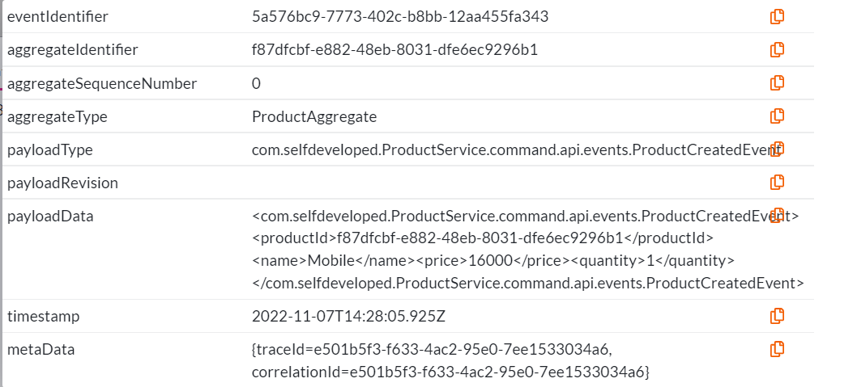

So, In this way you can create the Query and Command differently for your Command API and Query API using the CQRS. Now one more thing when are you working with the Event Driven Architecture handling the exception and handling the transaction is very important. So. Let’s see one example…

Now go to the Product Event Handler where we are handling this particular Product Created Event.so at this particular point I am saving the data I mean at this particular point my transaction should be committed right?

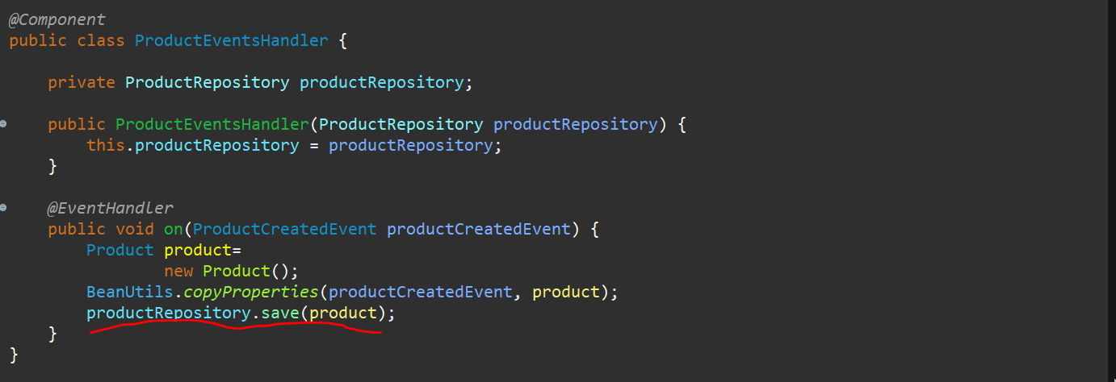

Because there is no error but after that if there are any error occurred. So, after this adding the data I am throwing the data over here.

Now after saving the and throwing the exception now what will happen to our application let’s see that.

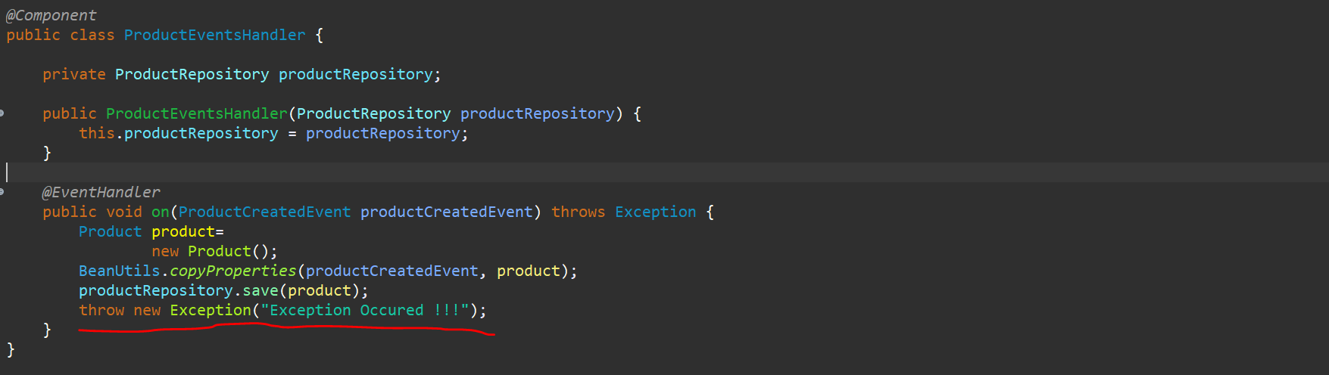

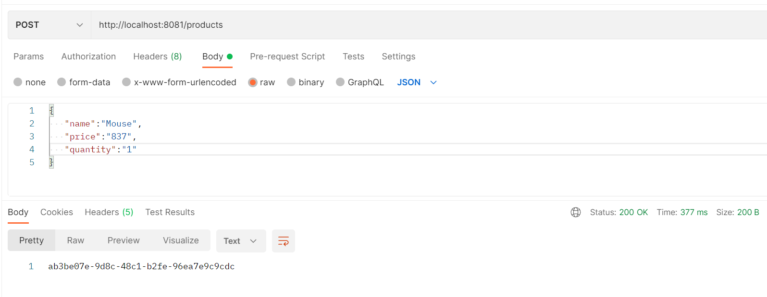

Here you can see that though we have added the exception postman request got success…

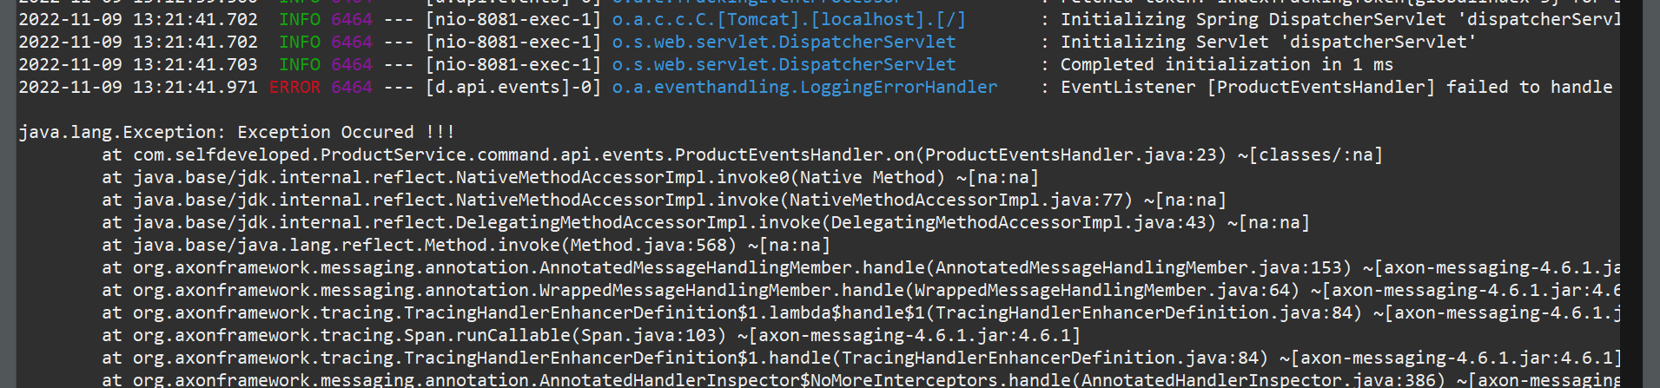

If u go to console exception occurred.

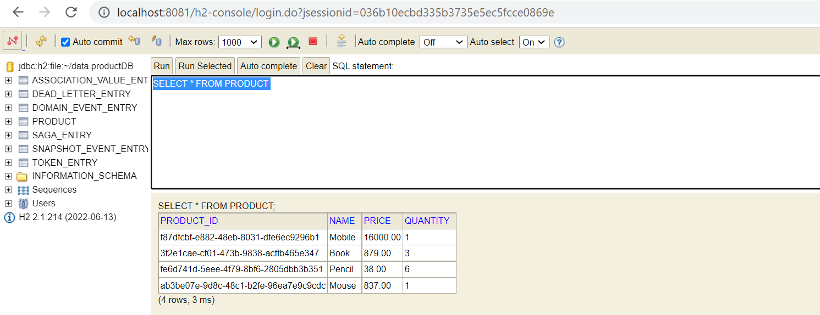

If u go to particular h2-console you can see data has been stored as well. Which is not I want right because there is an exception so that particular transaction should be revert it back. Ideally other than Event Handler wherever an exception occur it’s handled perfectly fine.

But whenever there is an exception in the Events you need to propagate that particular exception to all the places from where that particular command is been created that is the Controller layer as well. So, whenever an exception occur when u are handling the particular exception also it should **Rolled back** the particular **Transaction**.

So, In this point what we need to do it we need to implement the **ListenerInvocationErrorHandler**.

So, whenever there is an error in our Event Handler, we need to propagate that particular error. So let me create a package **exception** in **command.api**. let’s create a class with name **ProductServiceEventsErrorHandler.** Thisparticular class implements **ListenerInvocationErrorHandler**.

Let’s add the unimplemented method i.e **onError**. And from here I will just do throw exception.

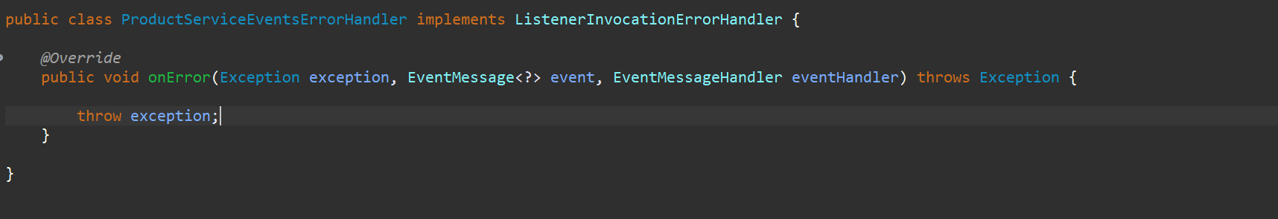

So, here we can see that this is handling our event messages. So, whenever there is an exception in our events, we are just re-throwing that particular exception.

Now we need to register this particular in our application. So go to the main class over here.

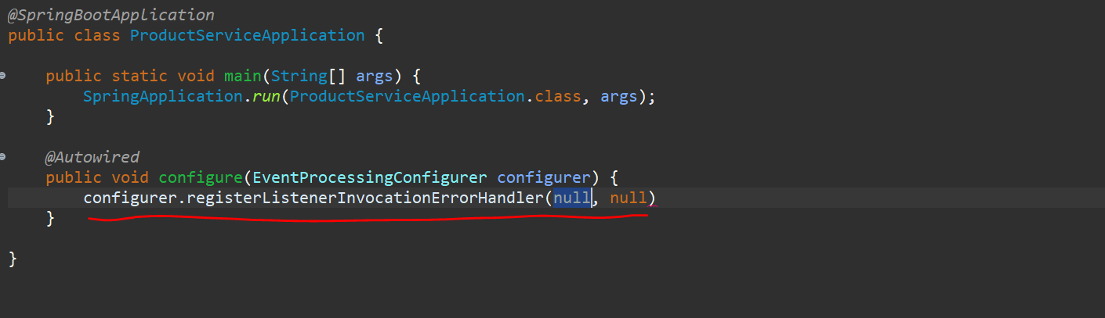

Here you can see that it is taking string as well as function.

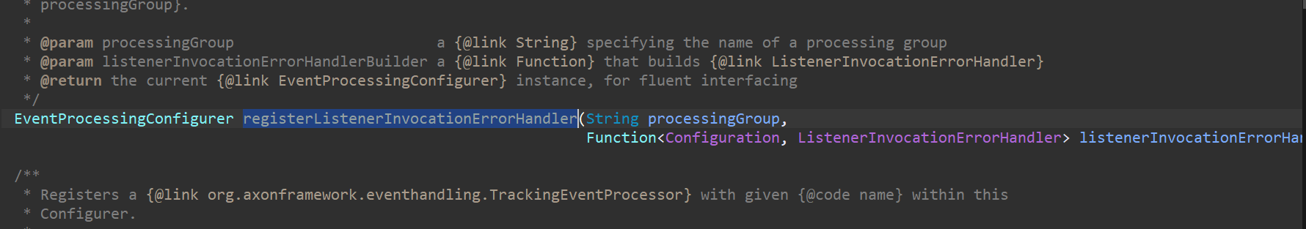

So, I will provide the string as **product** and function.

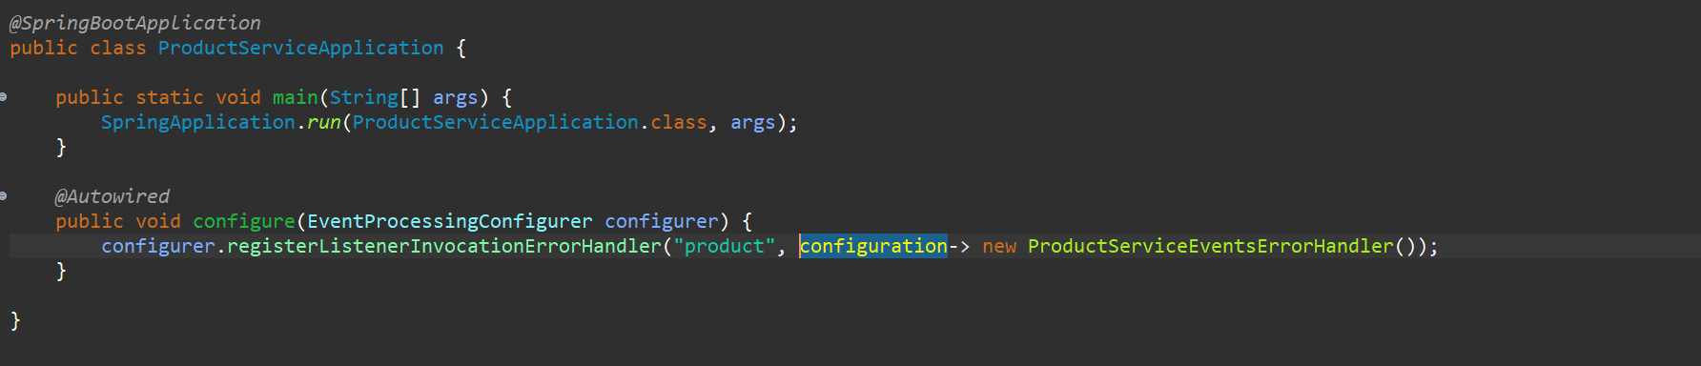

So, this is the one which we registered over here.

Now we need to use this particular string “**product**” in our Event Handler. So, let’s go to the **ProductEventsHandler** and we define one annotation @**ProcessingGroup(“**product”) over here.

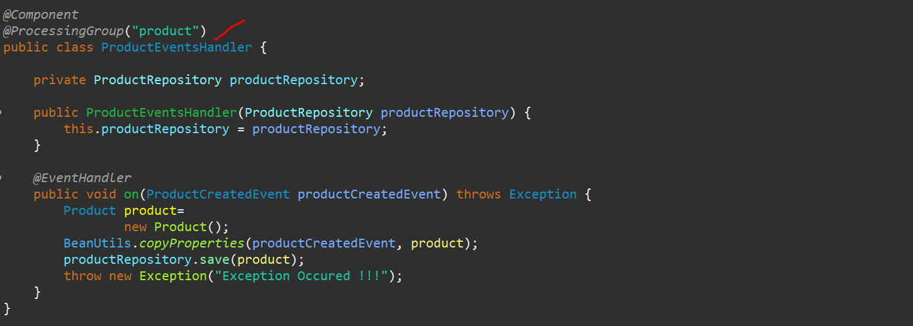

Now at these particular points we can handle the different exceptions that has been occurred over here. so, what I will do I will just create a method and I will annotate this with @**ExceptionHandler** of the axon framework not the spring framework. And from here I will just throw the exception back. Now here you can add the logger as well.

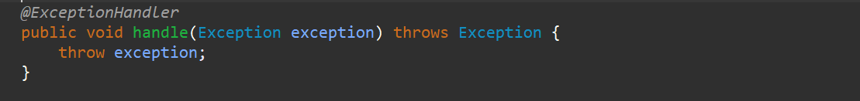

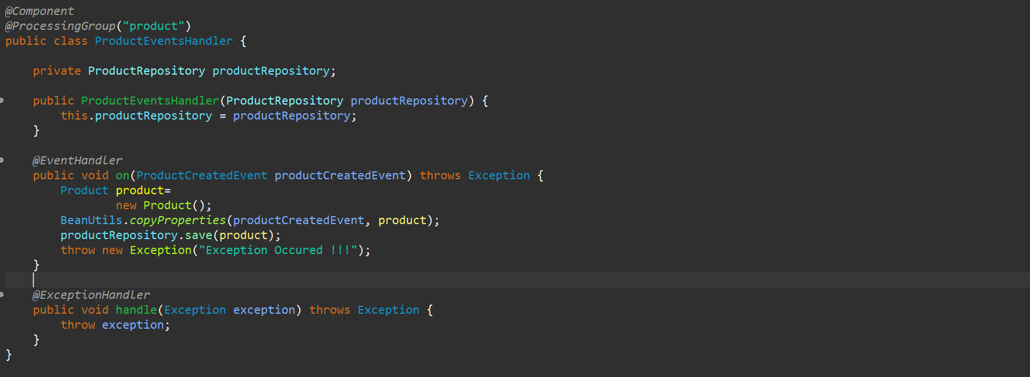

Now let’s run this and test it out. Make sure axon server is running…

Now let me try it to save Temp data ---

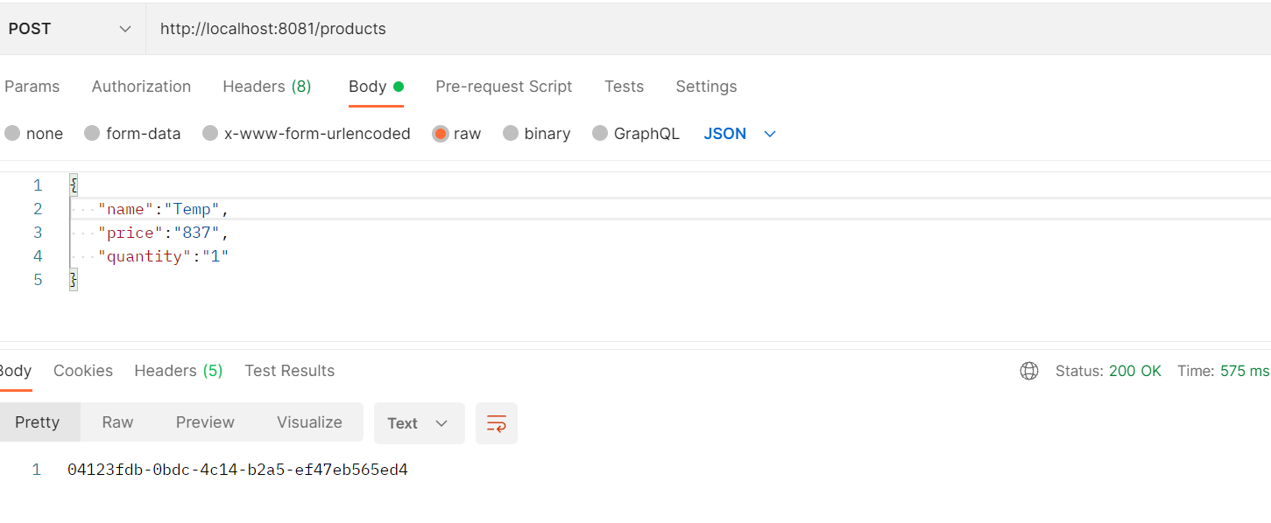

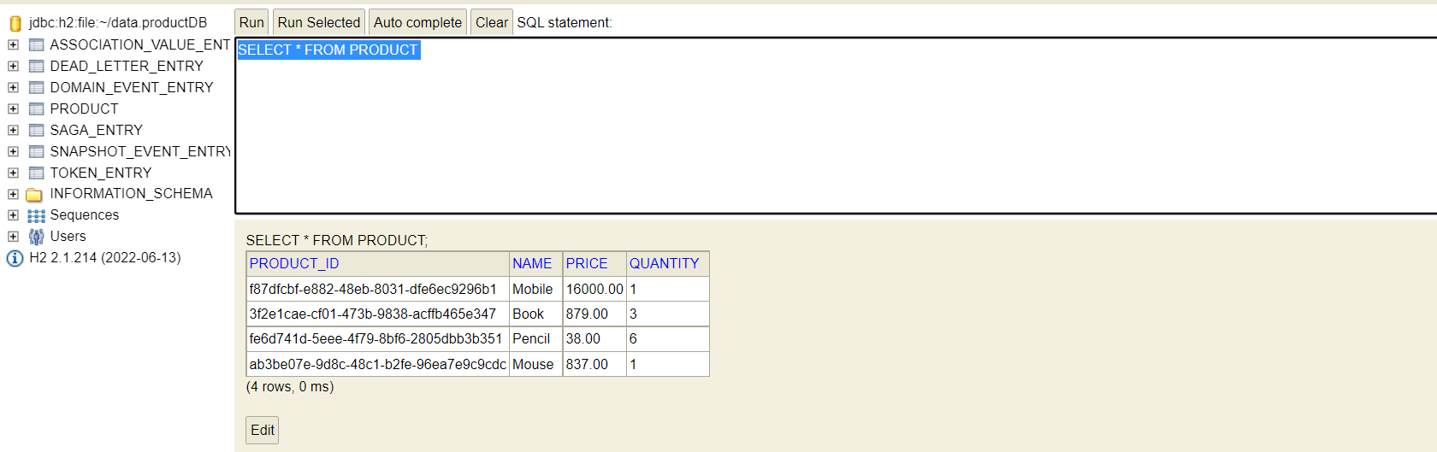

So, here you can see that the particular Temp data not stored over here. because we just handled the events. So currently we have not done anything to the throw back the error to the particular Rest API. So, this is just we are handling the particular exception over here. whenever there is an exception that particular transaction will be rolled back over here for now, but we can handle this particular exception to get that particular exception message to the user as well.